Lab2 Report

Tips:

Machine A IP=10.0.2.5 Name: Ayase

Machine B IP=10.0.2.15 Name: Kirino

Machine C IP=10.0.2.6 Name: Kanako

Machine A has another NIC only for SSH connection with host Windows PC, ip address is 192.168.56.101

The SSH window is terminal of Mahcine A

## 2.1 Task 1: Using Firewall

Prevent A from doing telnet to Machine B.

Before:

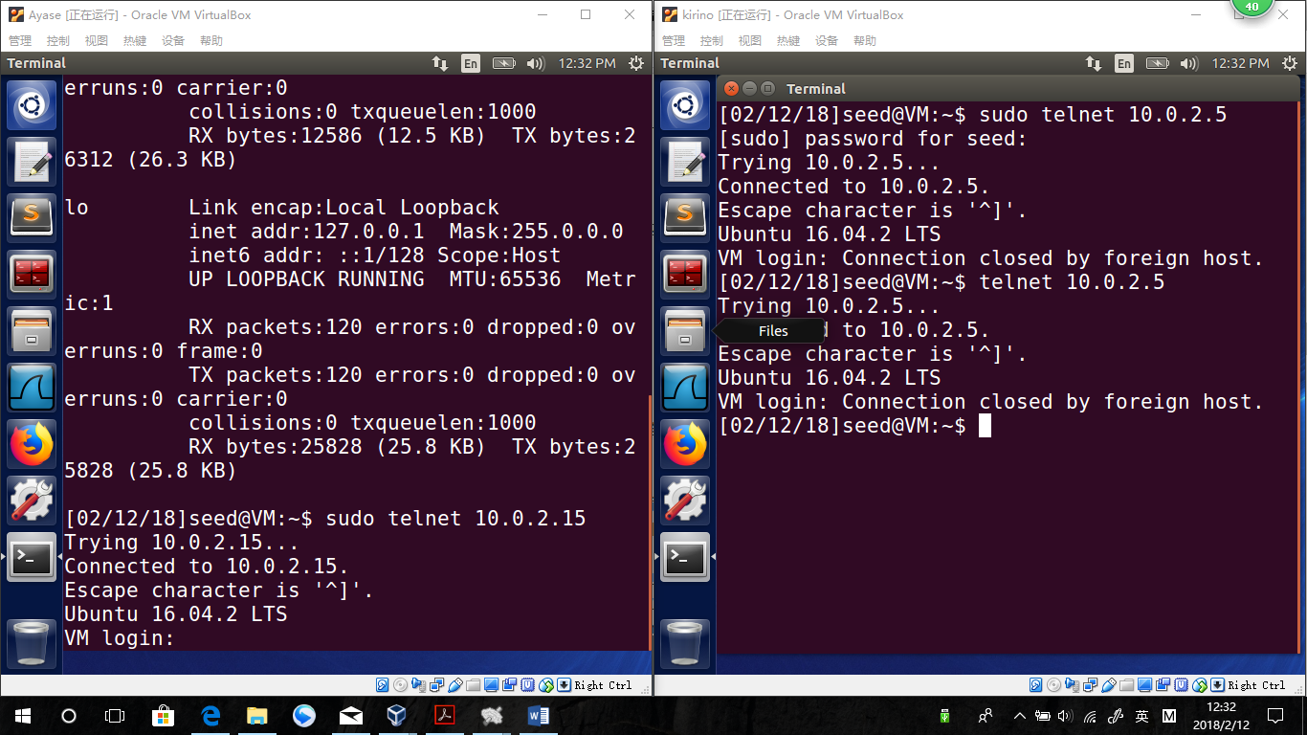

Sudo ufw deny out proto tcp from 10.0.2.5 to 10.0.2.15 port 23

After:

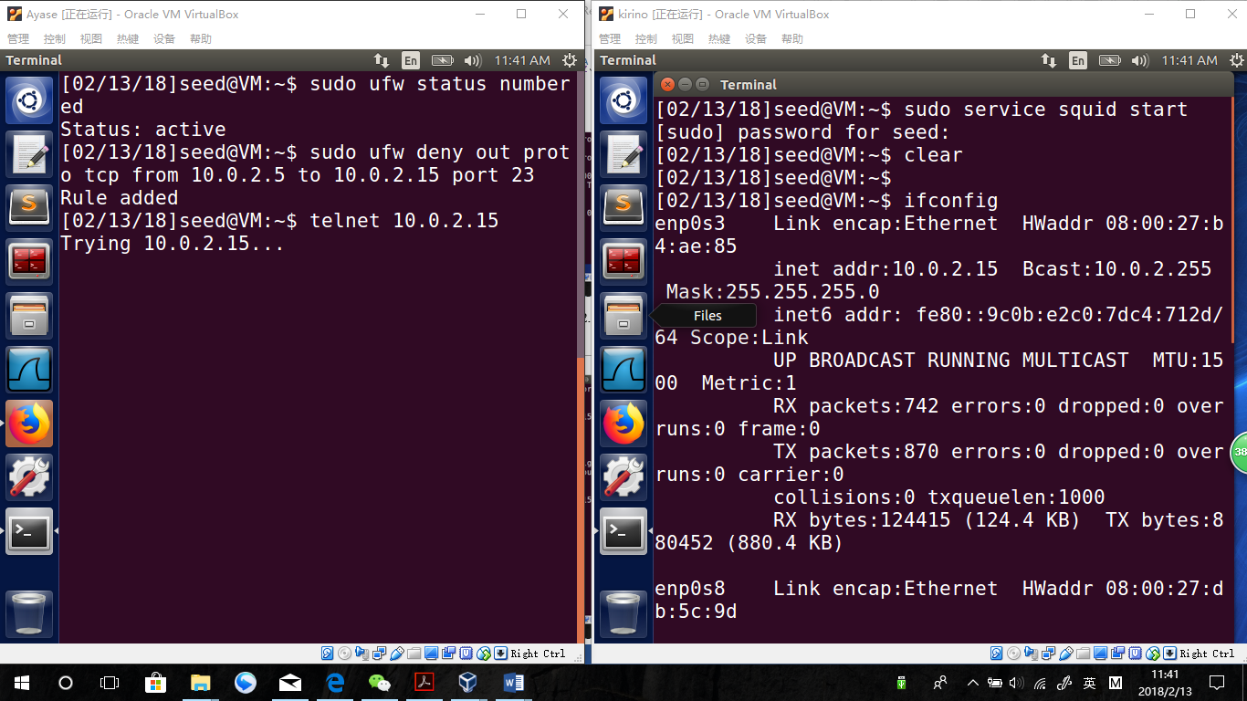

Observation:

The telnet did not succeed. The new rule prevent Machine A from doing telnet to Machine B.

Prevent B from doing telnet to Machine A

Before:.

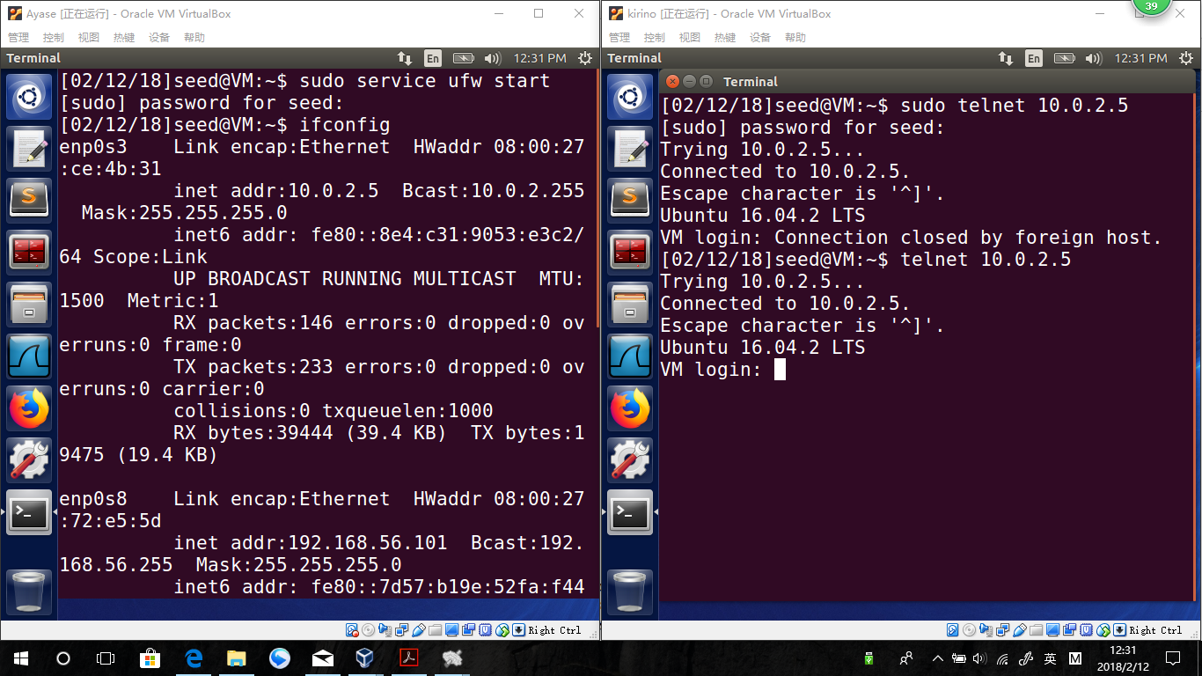

Sudo ufw deny in proto tcp from 10.0.2.15 to 10.0.2.5 port 23

After:

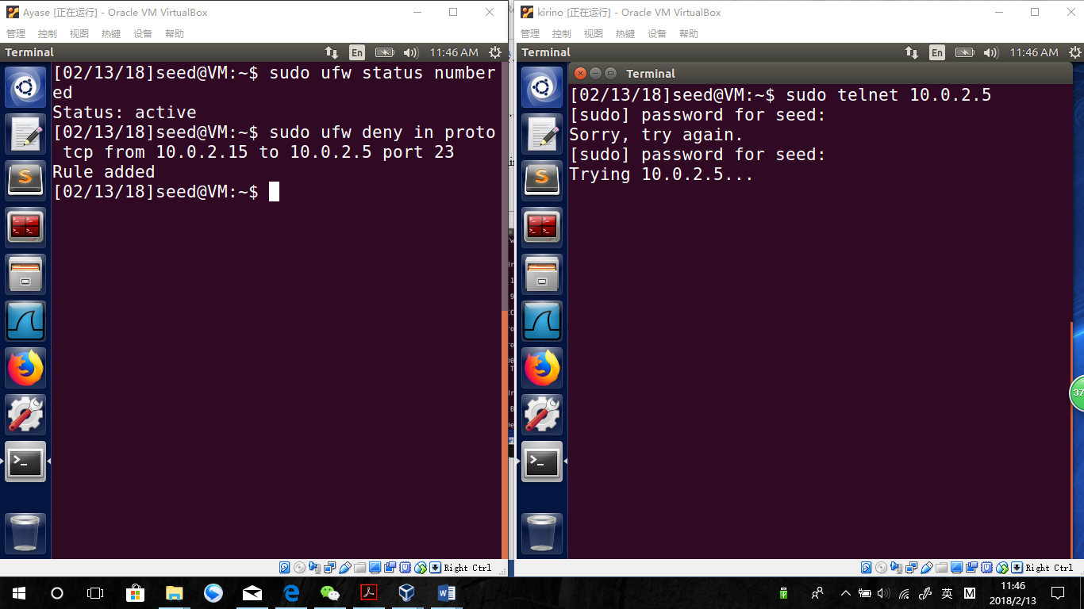

Observation:

The telnet did not succeed. The new rule prevent Machine B from doing telnet to Machine A.

Prevent A from visiting an external web site. You can choose any web site that you like to block, but keep in mind, some web servers have multiple IP addresses.

I decide to block [www.syracuse.edu](http://www.syracuse.edu) which ip is 128.230.18.198

Before:

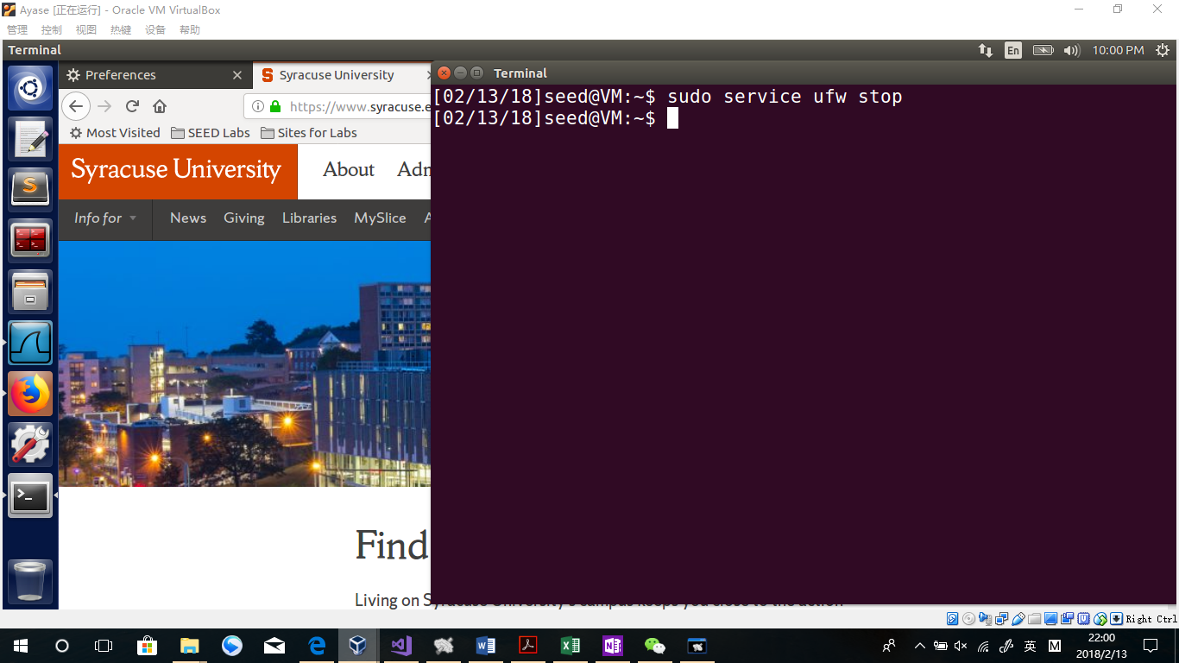

Sudo ufw deny out from any to 128.230.18.198

After:

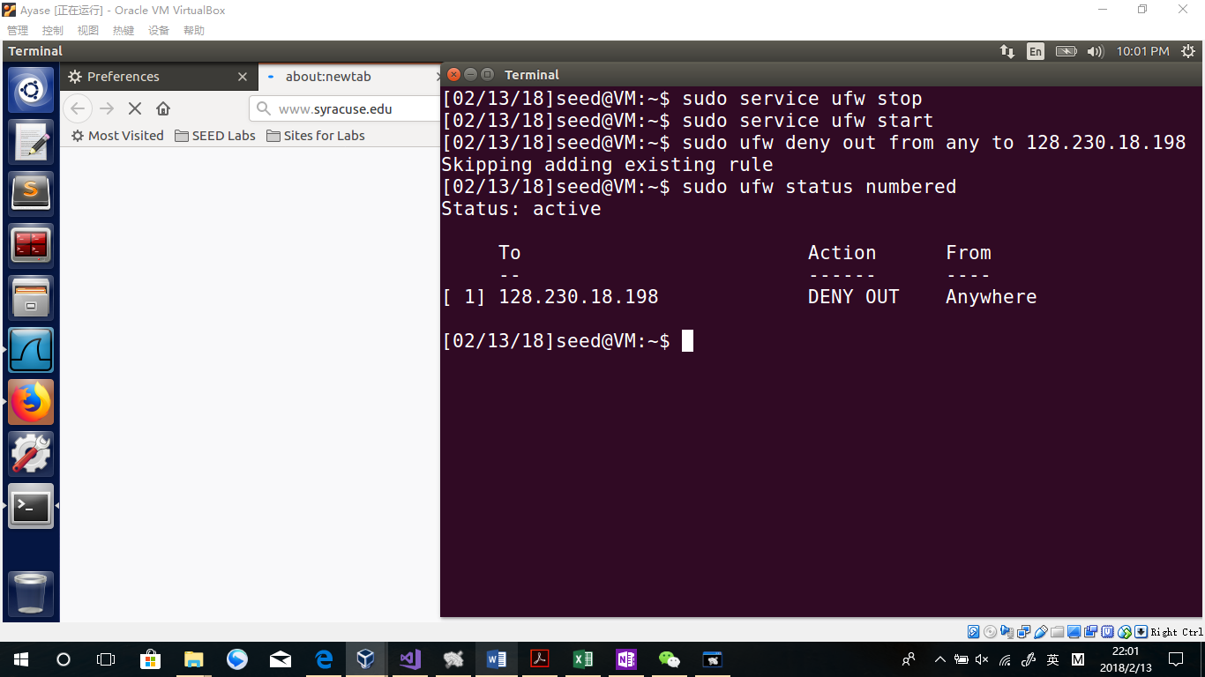

Observation:

The website is not allowed. The rule runs good.

Explanation:

In settings I give machine A multiple NICs, which is the reason why I would not use 10.0.2.5 but any to do this task. In other cases, any can be changed to the only ip address. Since I can only write one rule in the task, I need to use any, although it prevents sniffers of other PCs in the same network visiting [www.syracuse.edu](http://www.syracuse.edu) .

## Task 2: How Firewall Works

Five different rules:

Rules of the previous task:

//Rule1 not allow this PC to receive telnet.

bool rule1 = iph->protocol == IPPROTO_TCP && tcph->dest == htons(23);

//Rule2 not allow this PC to send telnet.

bool rule2 = iph->protocol == IPPROTO_TCP && tcph->source == htons(23);

//Rule3 not allow this PC to visit SU websites.

bool rule3 = iph->daddr == in_aton("128.230.18.198");

Rules additions:

/*Rule4 not allow this PC to ping PC 10,0.2.15 or any PC to ping this PC

*telnetFilterHook.hooknum should be changed to NF_INET_PRE_ROUTING;

*/

bool rule4 = iph->protocol == IPPROTO_ICMP;

/*Rule5 not allow the port 22.

*Port 22 is used as my ssh connection, so when the program works, the ssh client should be disconnected.

*/

bool rule5 = tcph->source == htons(22);

Rule1 Test:

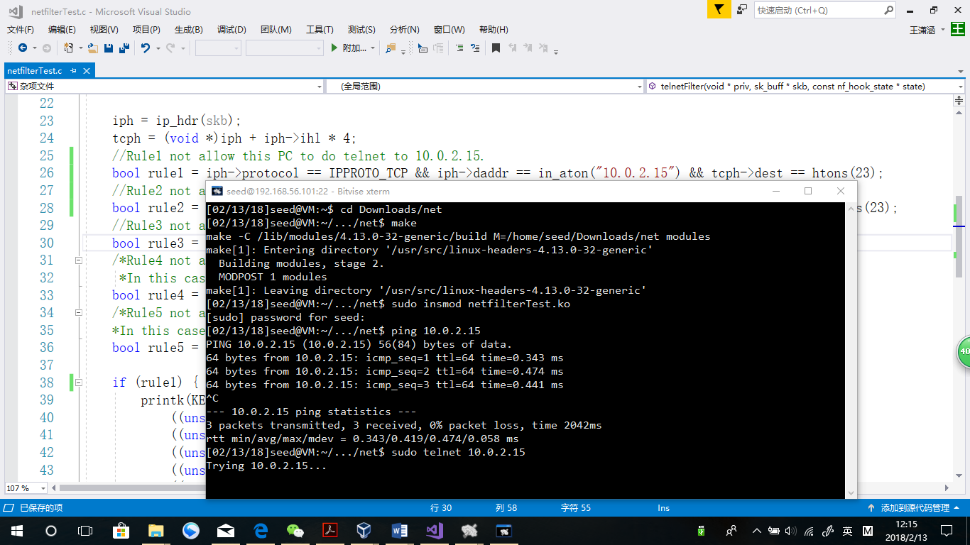

Remove Kernel:

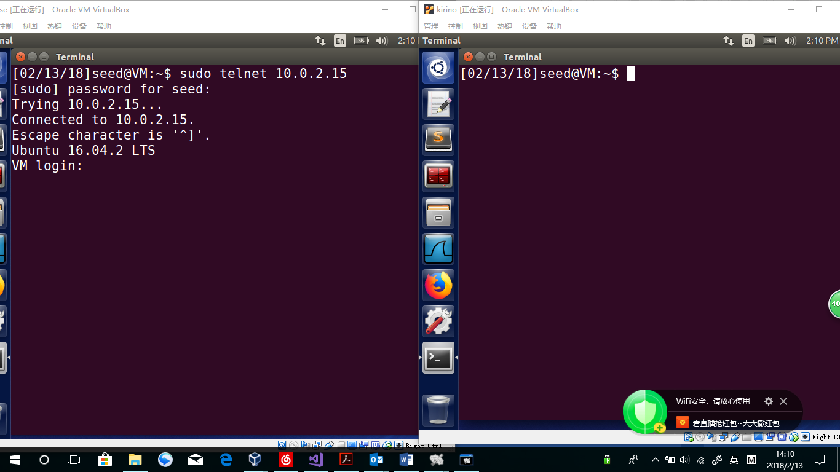

Observation:

Once the module installed, Machine A cannot do telnet to Machine B. But once the module removed, it recovers.

Explanation:

In the code, rule1 was set so that when a packet of A doing telnet to B, the Boolean rule1 will be true, and the telnetFilter method will return NF_DROP of unsigned int.

The telnetFilterHook.hook will be false so that the packet will not be hooked.

Rule2 Test:

Insmod

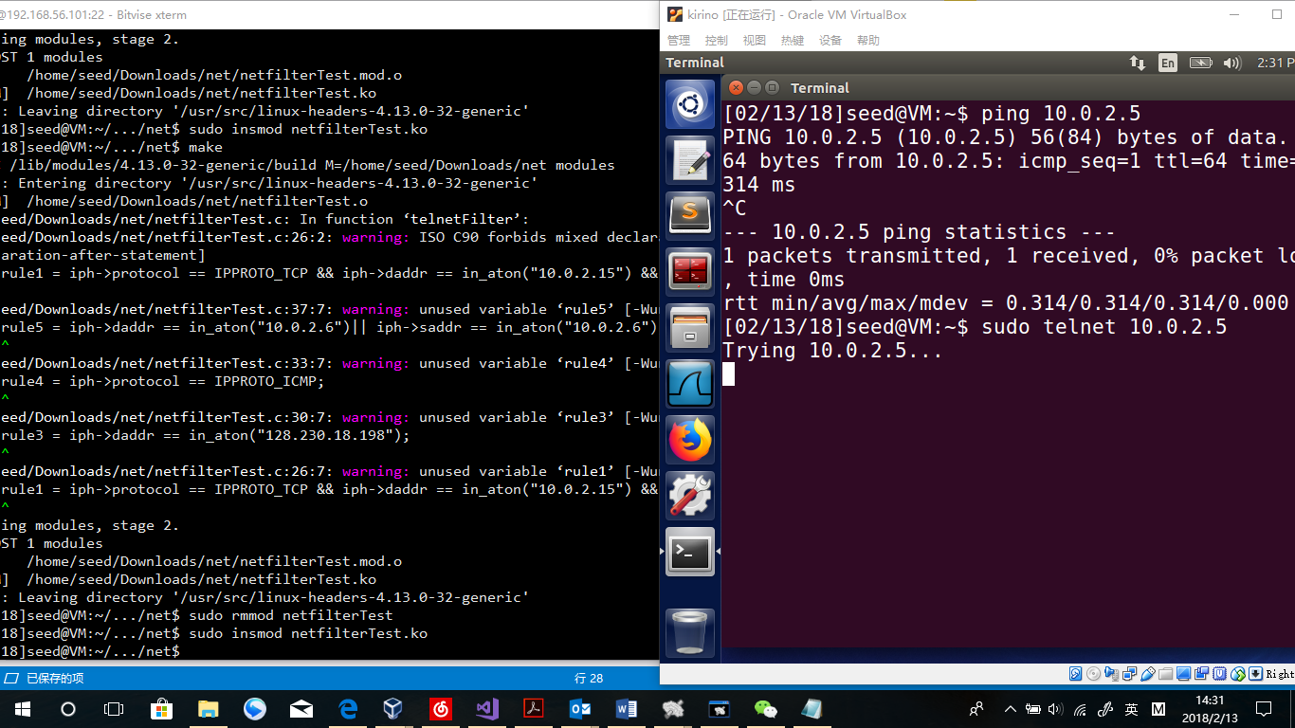

Rmmod

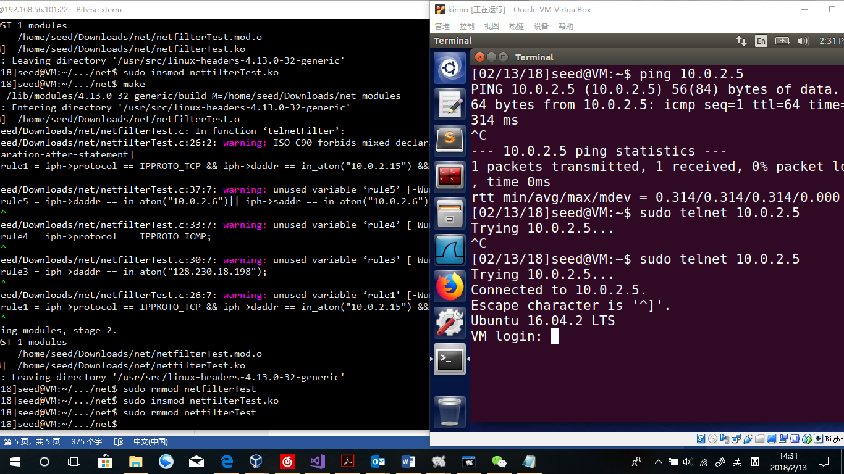

Observation:

Once the module installed, Machine B cannot do telnet to Machine A. But once the module removed, it recovers.

Explanation:

In the code, rule2 was set so that when a packet of B doing telnet to A, the Boolean rule2 will be true, and the telnetFilter method will return NF_DROP of unsigned int.

The telnetFilterHook.hook will be false so that the packet will not be hooked.

Rule3 Test

Insmod

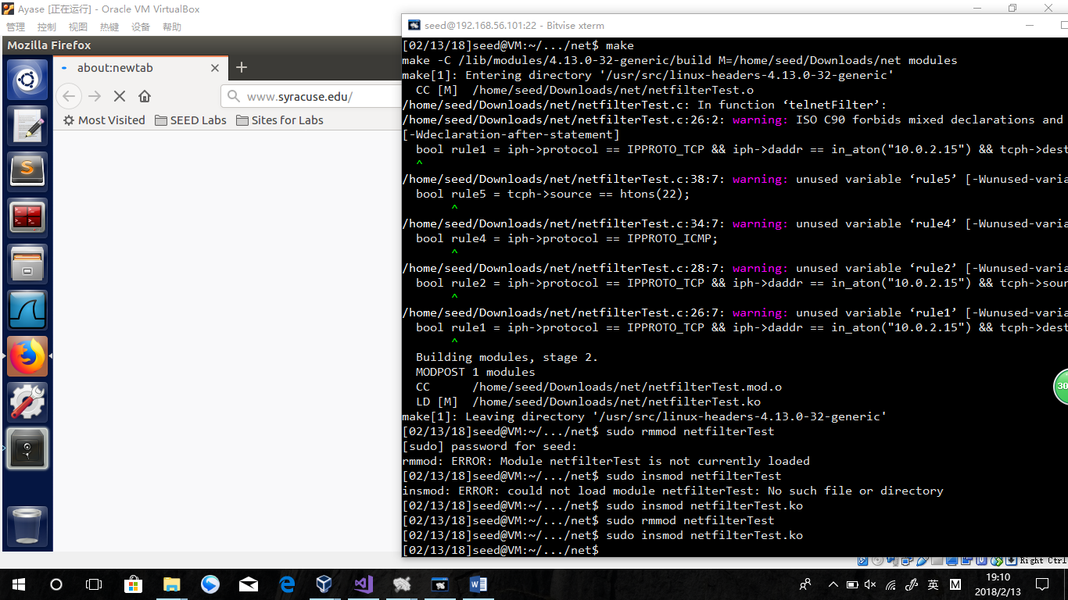  
rmmod

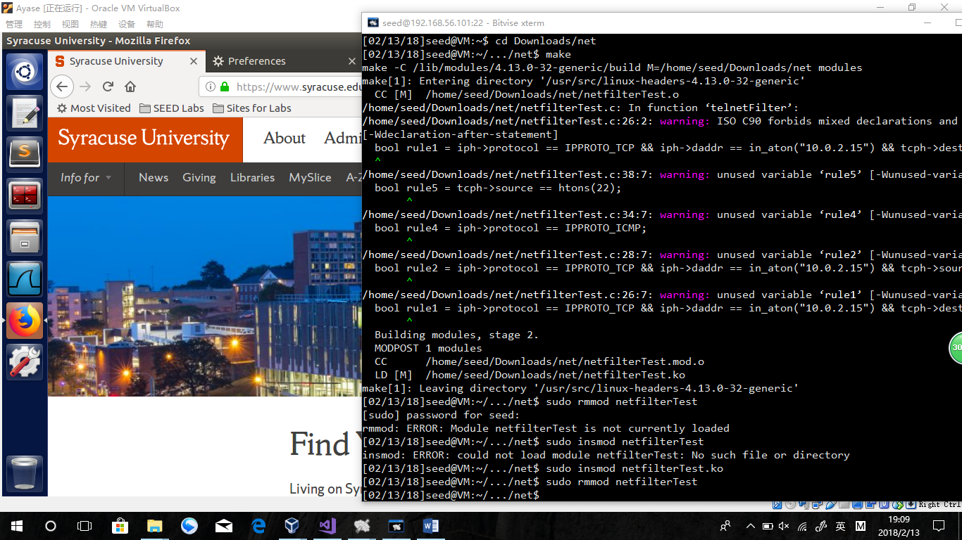

Observation:

Once the module installed, firefox browser cannot get contents of [www.syracuse.edu](http://www.syracuse.edu) . But once the module removed, it recovers.

Explanation:

In the code, rule3 was set so that when visiting 128.230.18.198(the ip address of [www.syracuse.edu](http://www.syracuse.edu) ), the Boolean rule3 will be true, and the telnetFilter method will return NF_DROP of unsigned int.

The telnetFilterHook.hook will be false so that the packet will not be hooked.

Rule4 Test

insmod

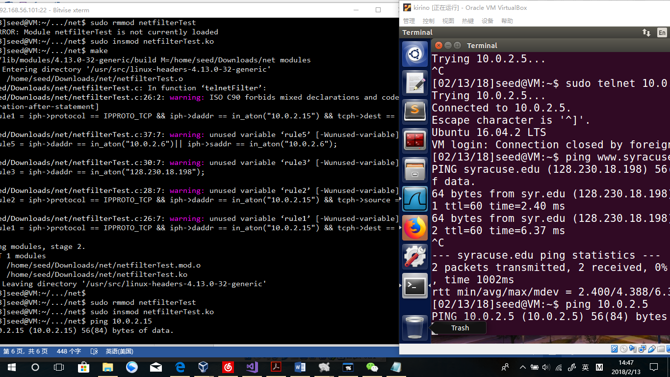

rmmod  
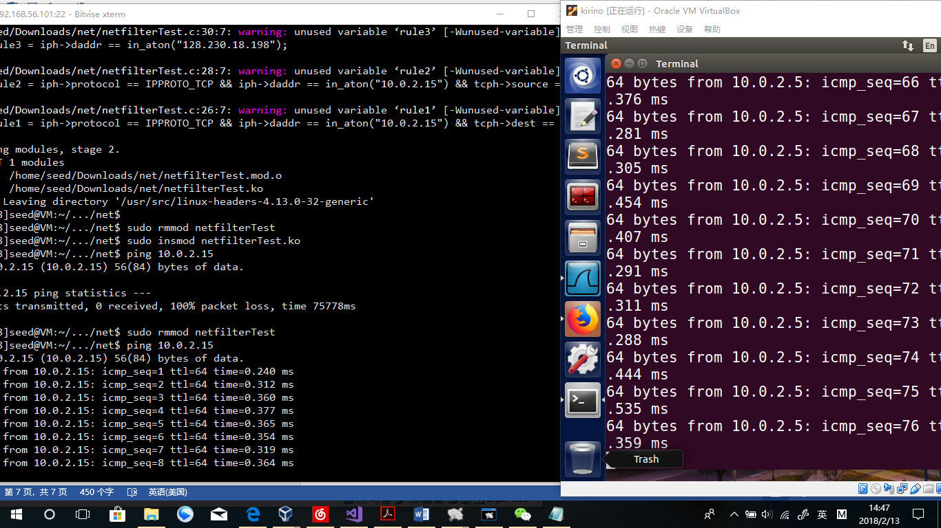

Observation:

Once the module installed, Machine B cannot ping Machine A and Machine A cannot ping Machine B. But once the module removed, it recovers.

Explanation:

In the code, rule4 was set so that all ICMP packets will let telnetFilter method return NF_DROP of unsigned int. The telnetFilterHook.hook will be false so that the packet will not be hooked.

Rule5 test:

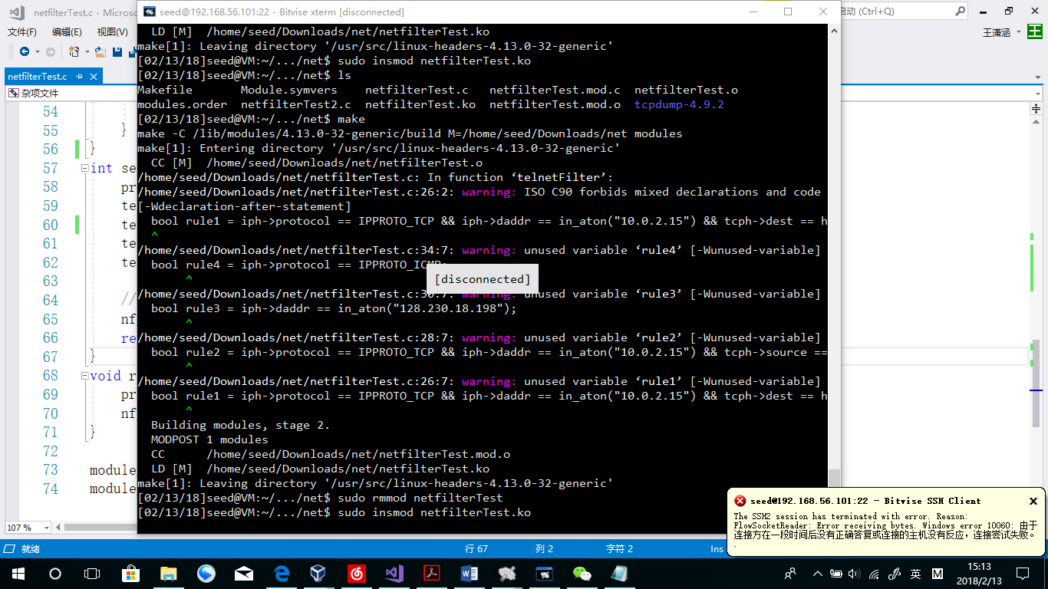

Observation:

Once the module installed, Machine A is still running, on the meanwhile the ssh connection crashed without any feedback.

Explanation:

In defaut settings, SSH is using the port 22. Once the net filter works, rule5 become true and telnetFilter method returns NF_DROP, so that the hook of ssh Is set to false.

**Question 1: What types of hooks does Netfilter support, and what can you do with these hooks? Please draw a diagram to show how packets flow through these hooks.**

Hooks: NF_IP_PRE_ROUTING; NF_IP_FORWARD; NF_IP_LOCAL_IN; NF_IP_LOCAL_OUT; NF_IP_POST_ROUTING

I can make rules in every hook to make a filter of network.



**Question 2: Where should you place a hook for ingress filtering, and where should you place a hook for egress filtering?**

Egress: NF_IP_PRE_ROUTING

Ingress: NF_IP_POST_ROUTING

**Question 3: Can you modify packets using Netfilter?**

Yes, I can.

**Task 3: Evading Egress Filtering**

Block:

I will use the programs I wrote in the previous task.

bool task3_1 = iph->protocol == IPPROTO_TCP && tcph->dest == htons(23);

bool task3_2 = iph->daddr == in_aton("128.230.18.198");

if(task3_1 || task3_2){…

The two Boolean represent the two conditions stated. Task3_1 forbids itself visiting any telnet server, and task3_2 forbids it visiting [www.syracuse.edu](http://www.syracuse.edu) website.

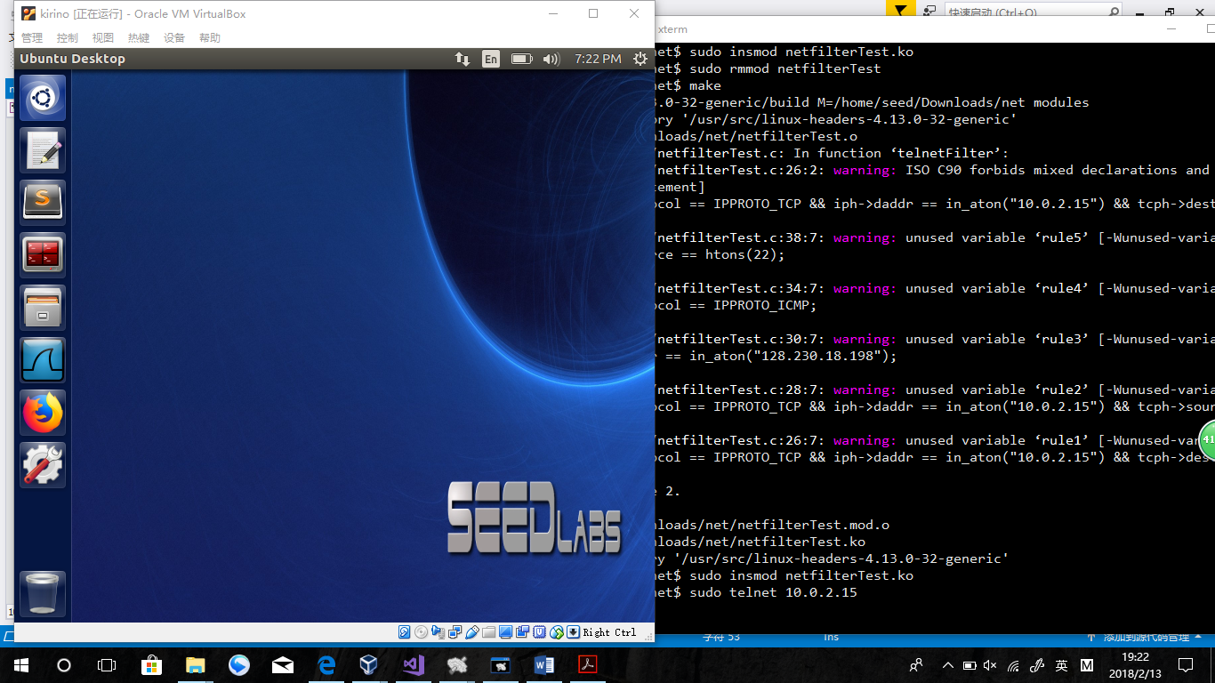

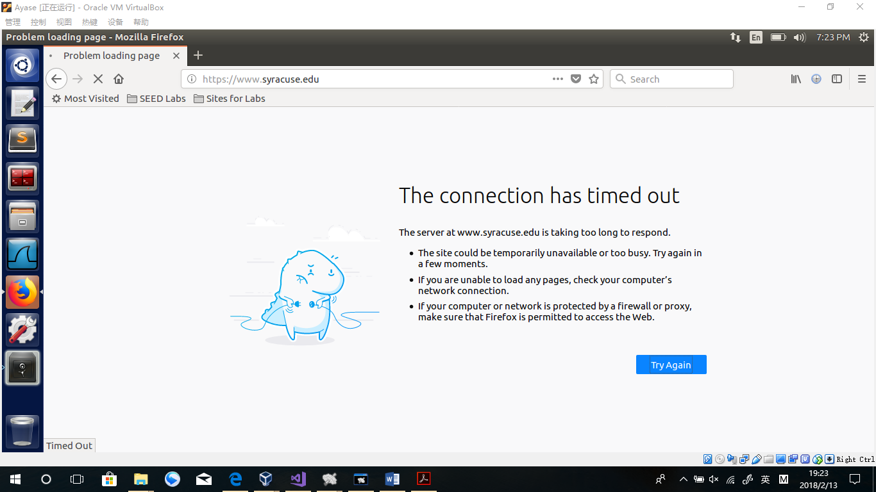

**Task3.a**

ssh -L 8000:Machine_C_IP:23 seed@Machine_B_IP

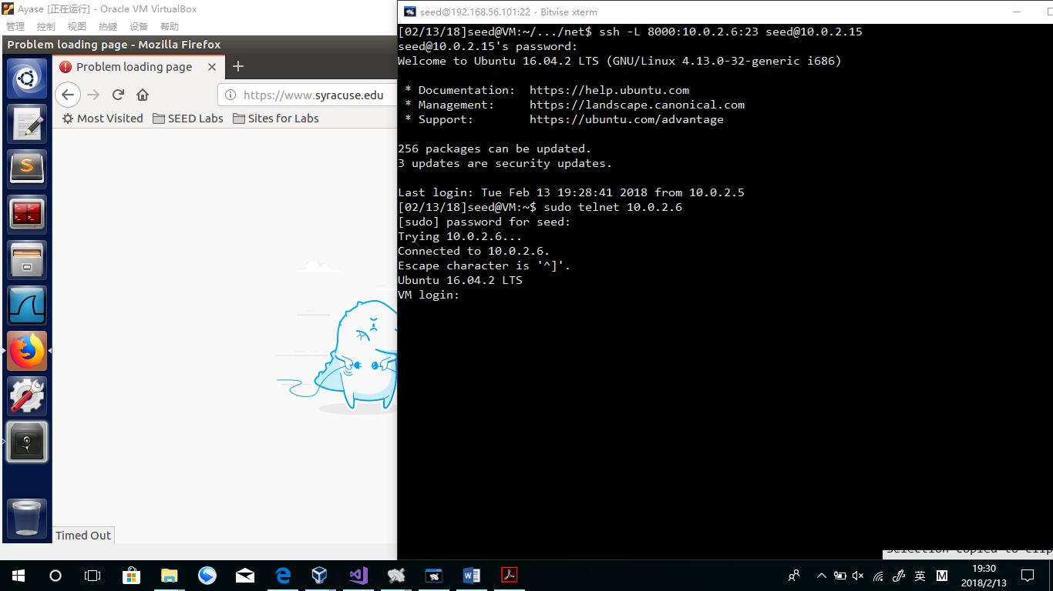

Observation:

The Telnet is done to Machine C successfully.

Explanation:

In fact, it is Machine B’s telnet request. It is shown in A’s terminal because of the ssh connection.

**Task 3.b: Connecting to Syracuse using SSH Tunnel.**

Just like stated before, the Machine A still cannot visit [www.syracuse.edu](http://www.syracuse.edu) .

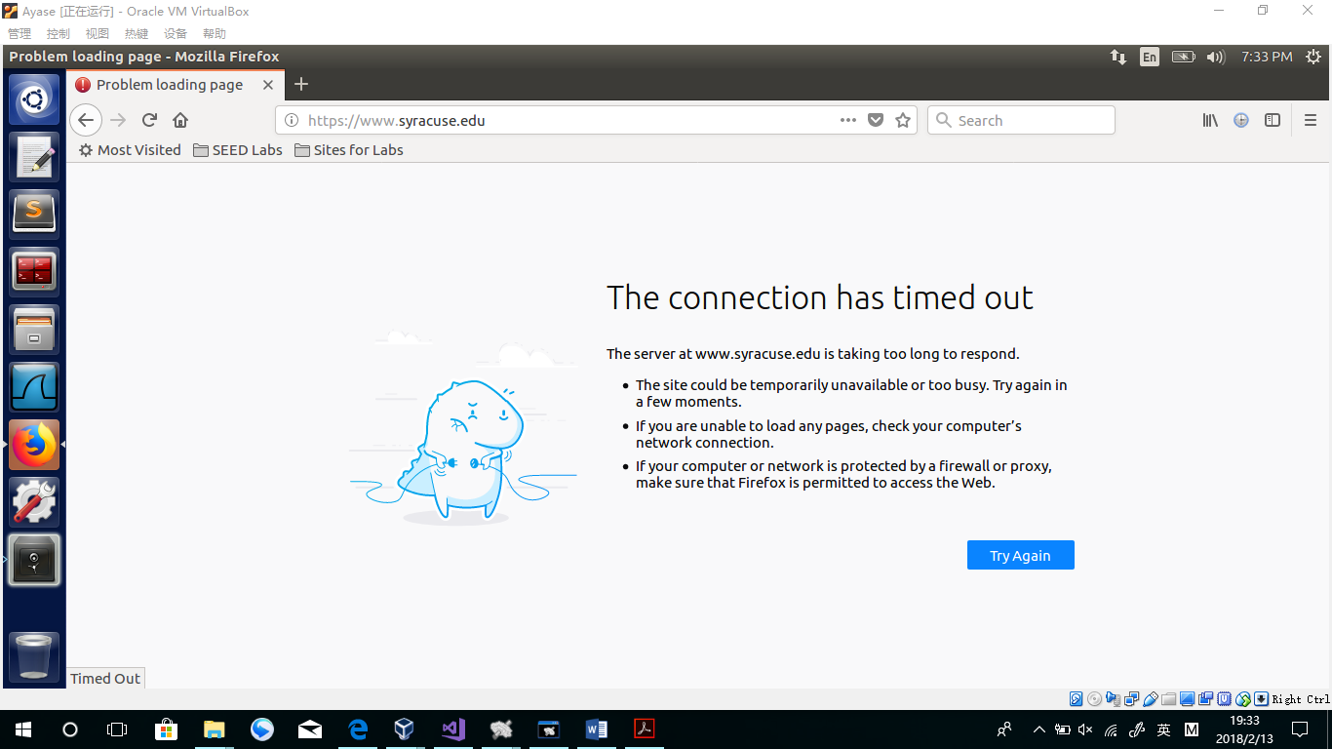

Settings of SSH:

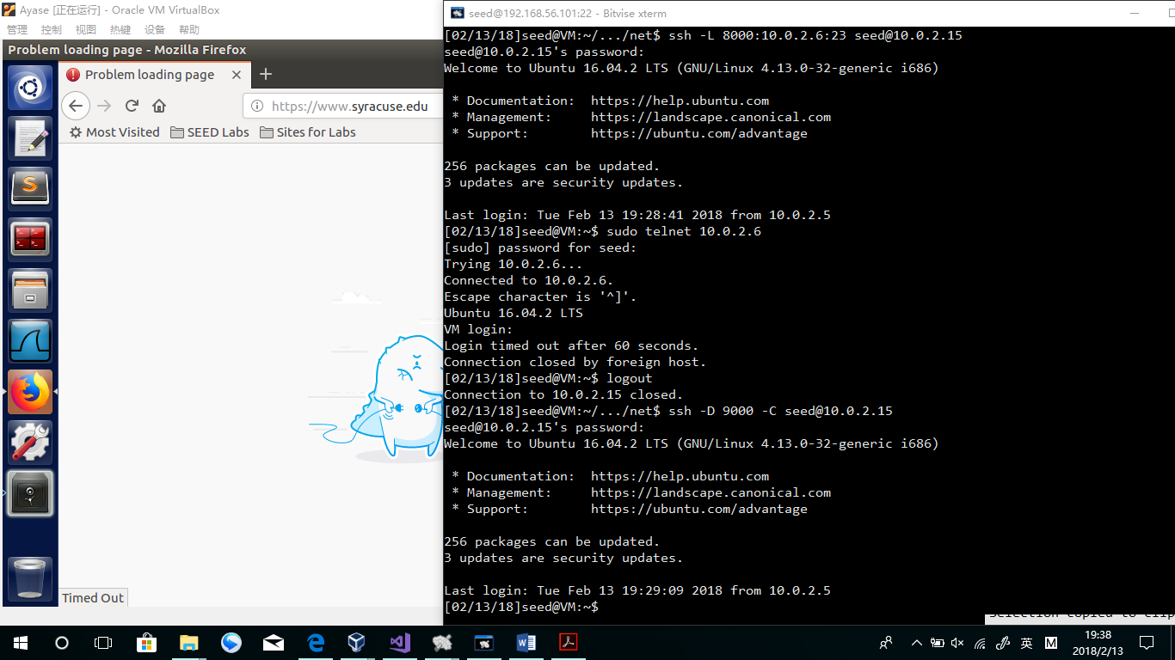

Settings of FireFox:

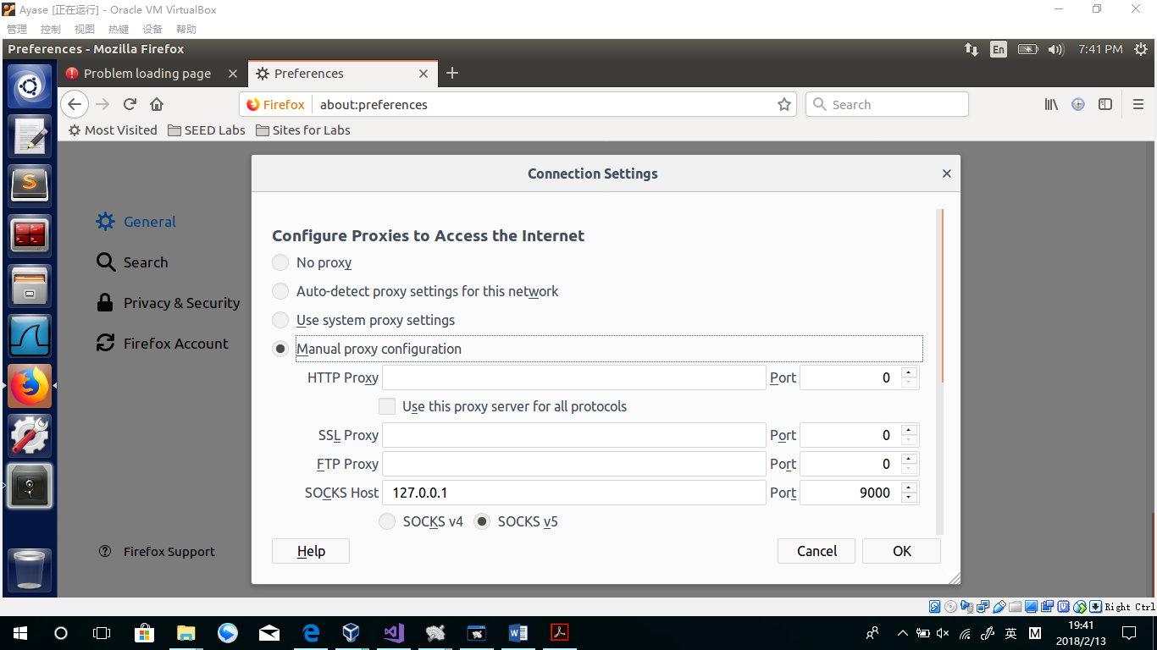

Reloading the website:

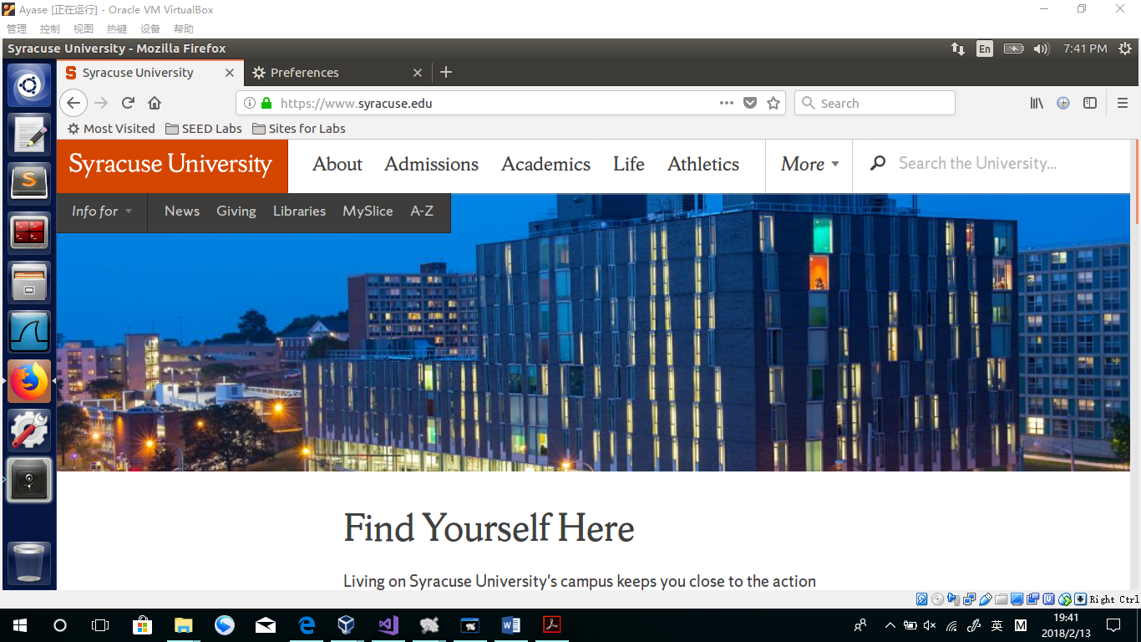

Observation:

After changing the settings in Firefox, the browser can visit [www.syracuse.edu](http://www.syracuse.edu) again.

Break the SSH:

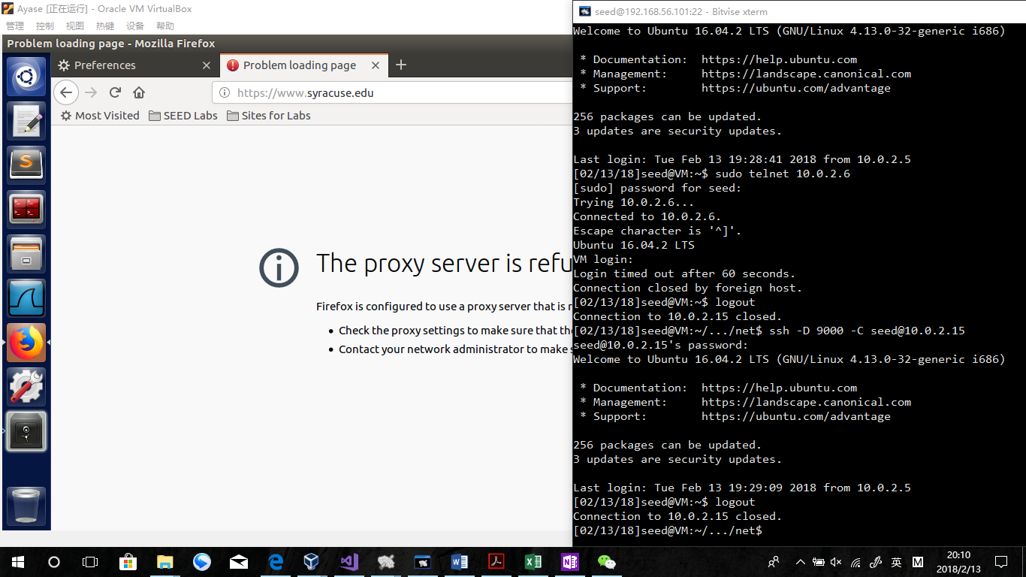

Observation:

After stopping the SSH connection, the browser can not visit [www.syracuse.edu](http://www.syracuse.edu) anymore. And in the page, it is said “The proxy server is refused”, which means, the proxy of port 9000 is still open, but not make effects.

Open SSH again:

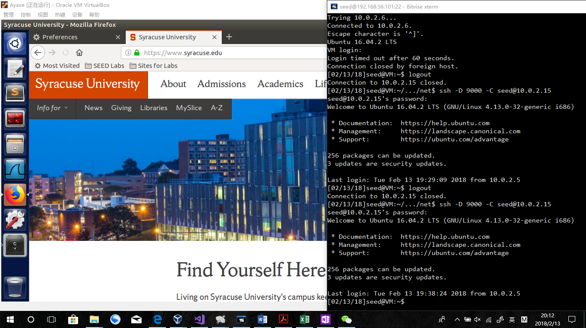

Observation:

The page came again!

Explanation:

In this task, port 9000 has been used as a proxy to receive sockets via Machine B (10.0.2.15). Because B can visit the website directly, the website contents has been sent to A from port 9000.

In the wireshark,

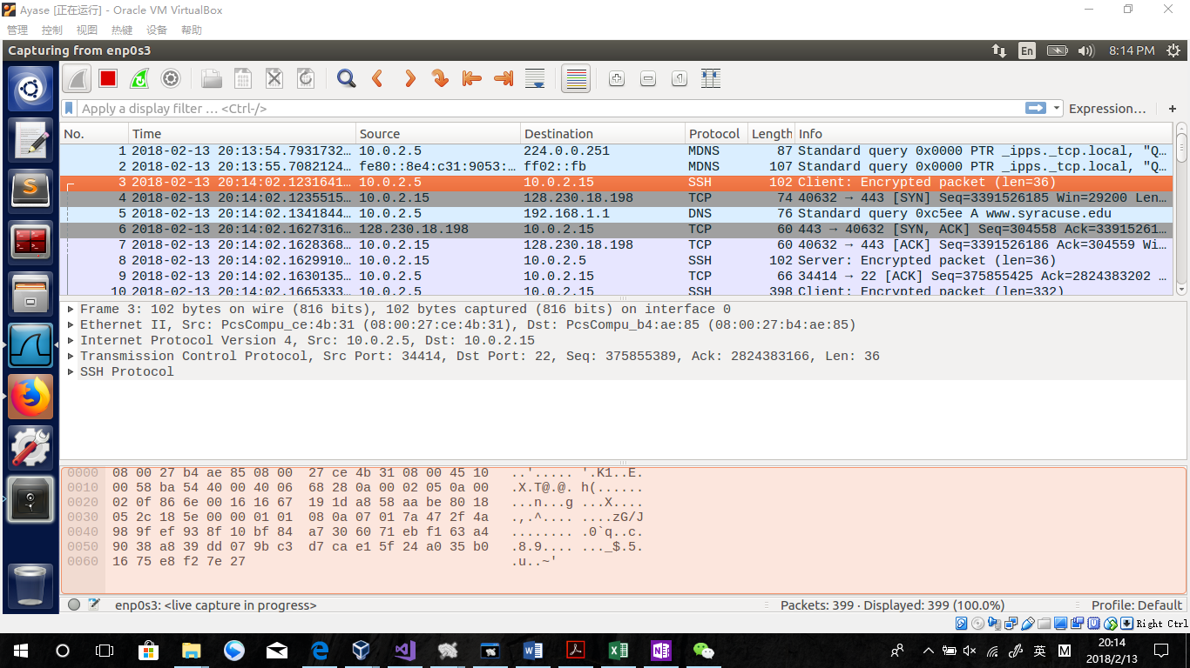

At first the Machine A send an encrypted SSH packet to its proxy Machine B for the page requests. Then, in the following line, Machine B visit [www.syracuse.edu](http://www.syracuse.edu) , and received TCP packets from the website. After the TCP connections (SYN and ACK) being done between B and the website, B has got all the TCP packets from the website. On the bottom of the list, the Machine B has SSH packets exchange with A to send packets got from the website. During this period, A and B confirm packets got from each other by sending ACK TCP packets.

**Question 4: If ufw blocks the TCP port 22, which is the port used by SSH, can you still set up an SSH tunnel to evade egress filtering?**

If I can reset another port as my SSH configure, the answer is yes. In this case, what I need to do is change SSH configure file and change the terminal command to the new port set in the SSH conf. Otherwise, no.

## Task 4: Web Proxy (Application Firewall)

**Task 4.a: Setup.**

1．

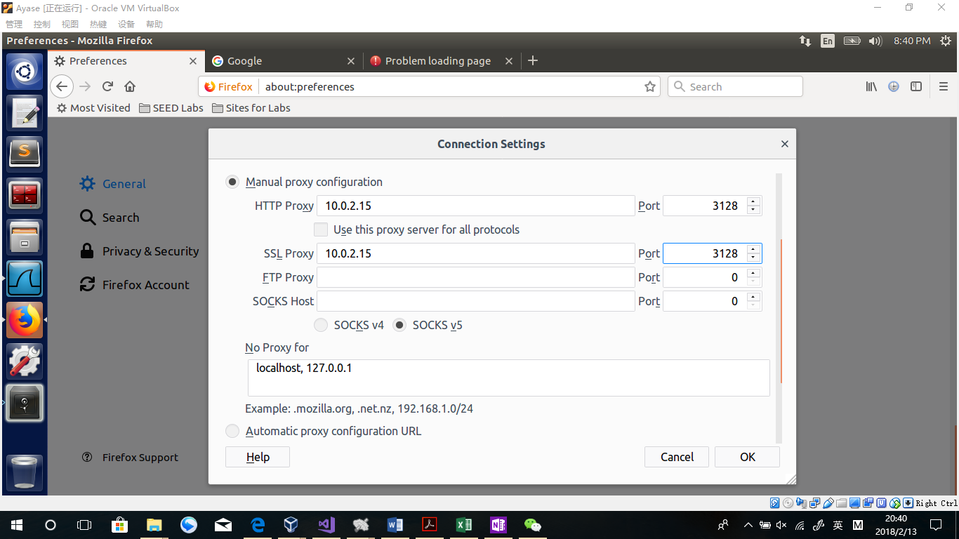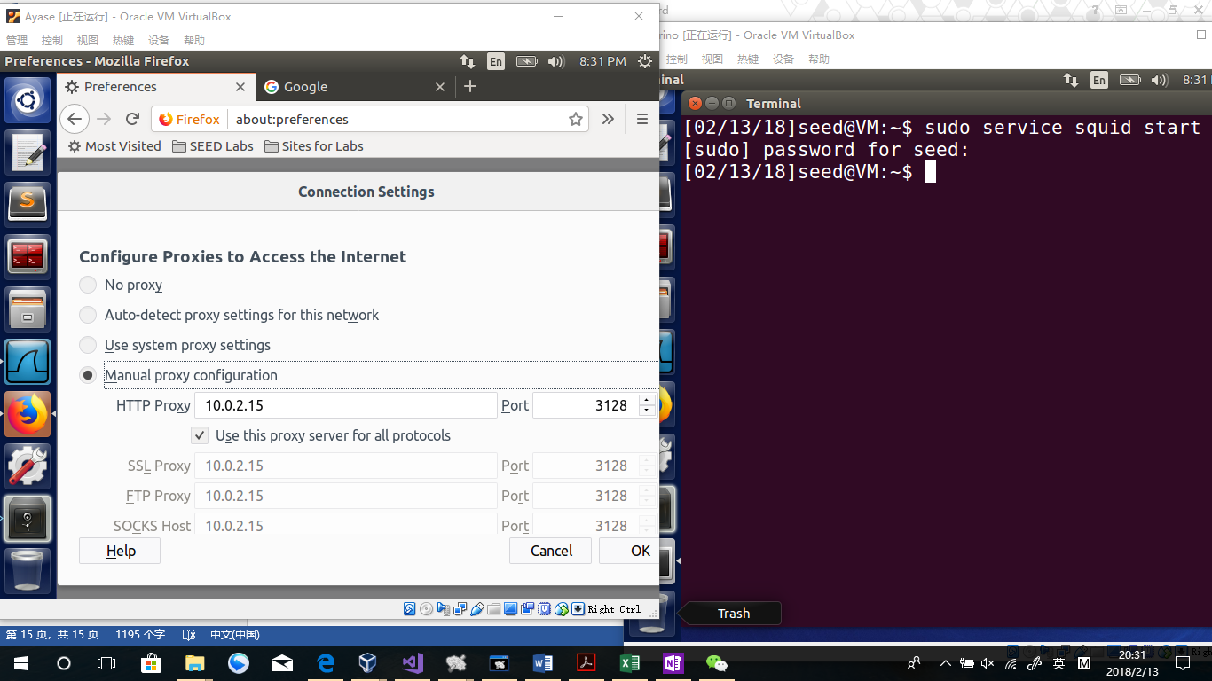

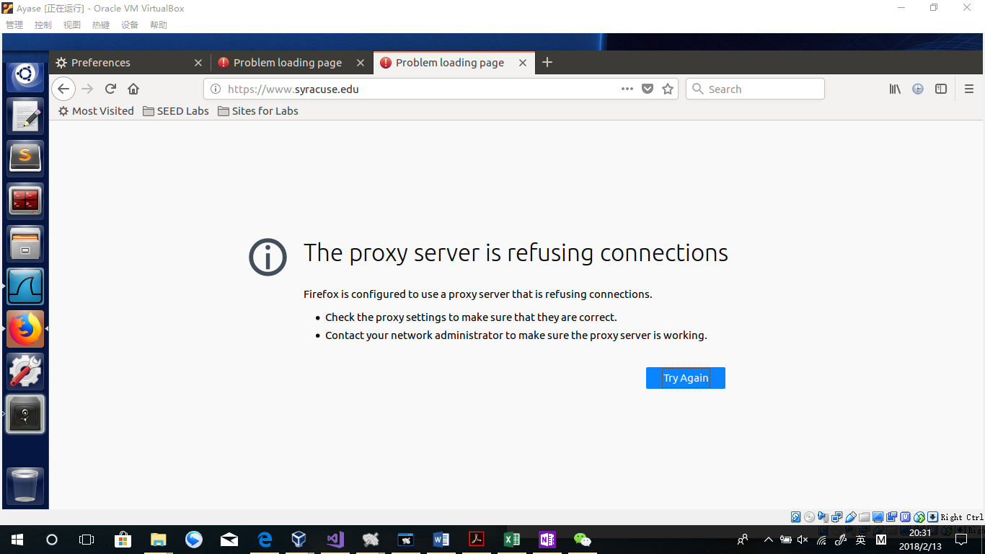

Observation:

All websites seem to be unavailable, including [www.google.com](http://www.google.com) and [www.syracuse.edu](http://www.syracuse.edu)

2.squid.conf

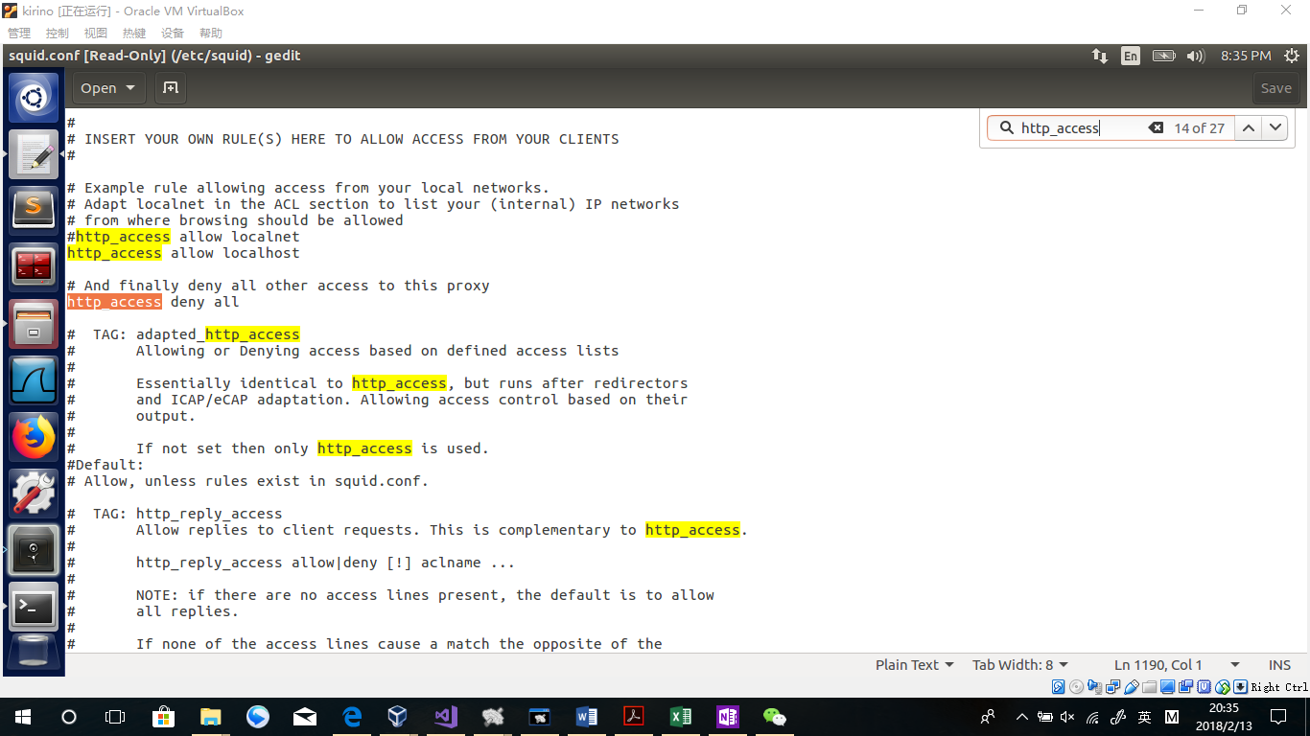

Explanation:

The “http_access deny all” setting is the reason why all websites are blocked3..

3.

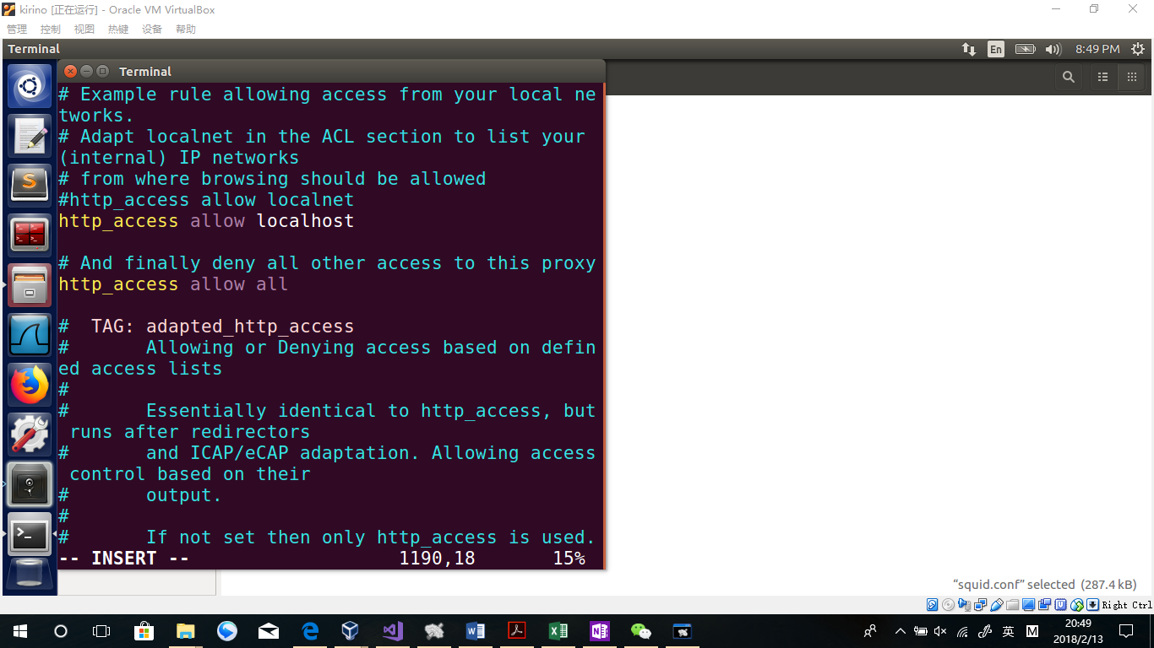

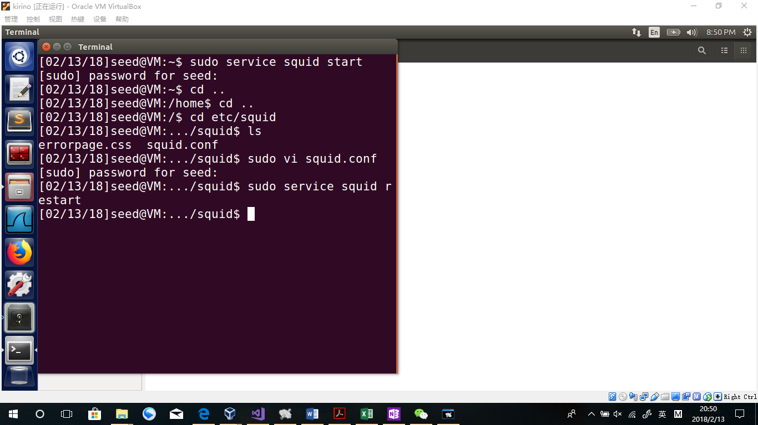

Change it to allow & Save the file & Restart the service

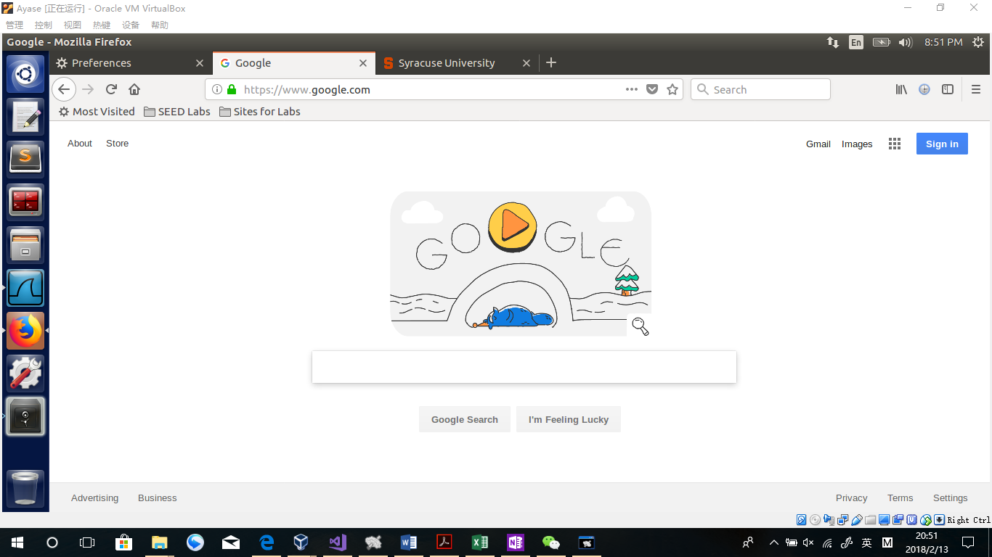

Observation:

After changing the squid.conf, firefox in Machine A can browse [www.google.com](http://www.google.com) as well as [www.syracuse.edu](http://www.syracuse.edu) .

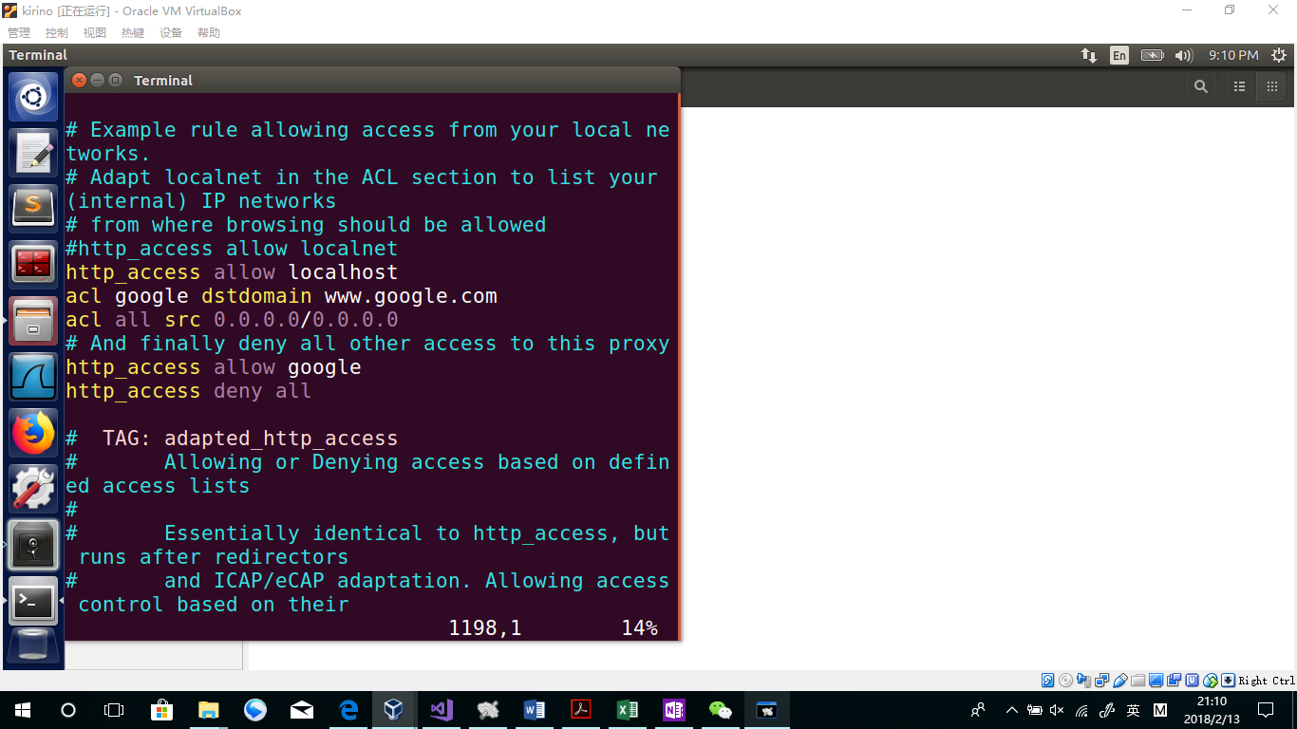

Acl google dstdomain [www.google.com](http://www.google.com)

Acl all src 0.0.0.0/0.0.0.0

http_access allow google

http_access deny all

SAVE& RESTART:

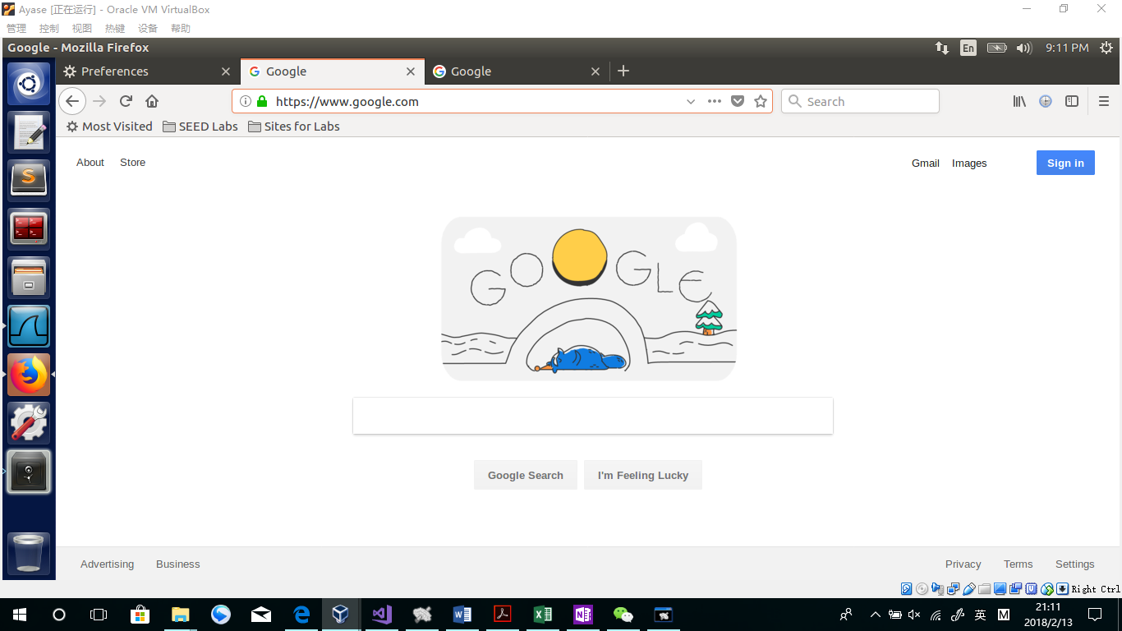

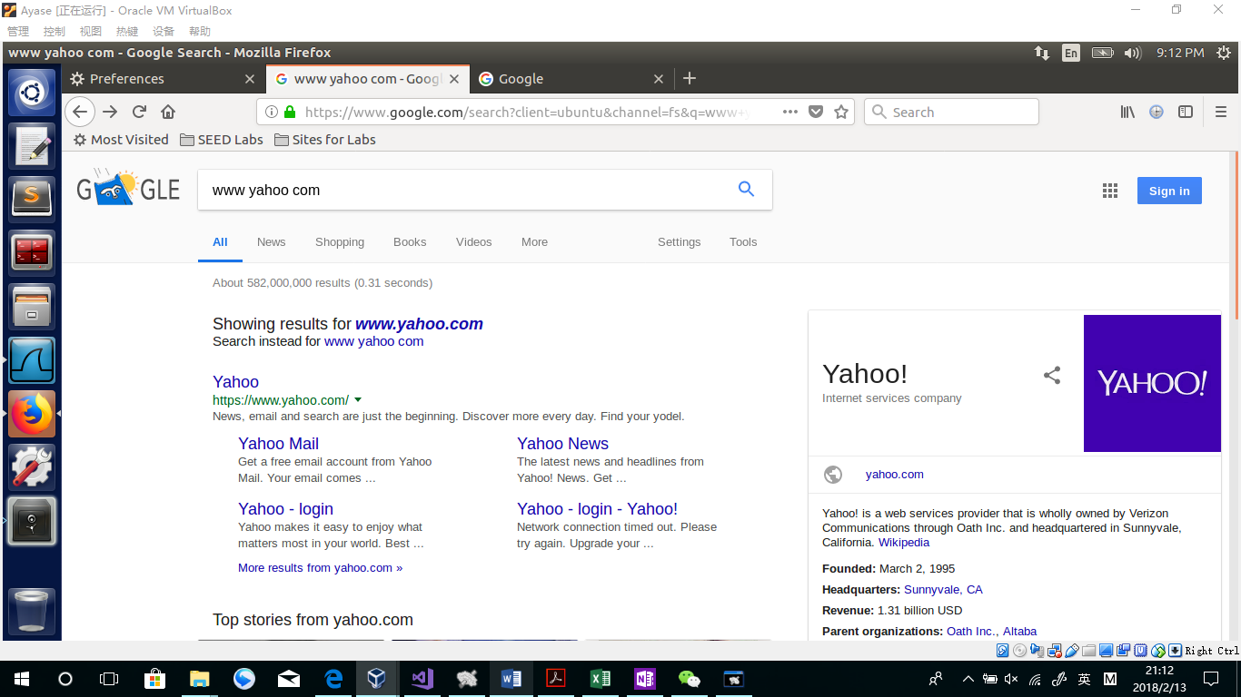

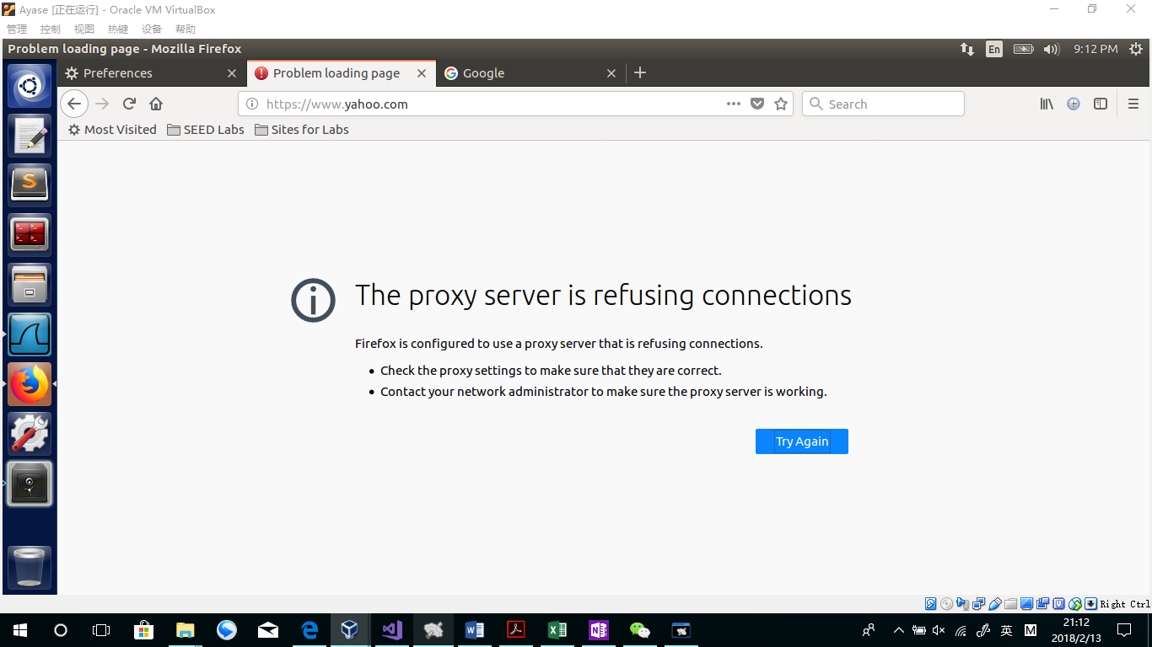

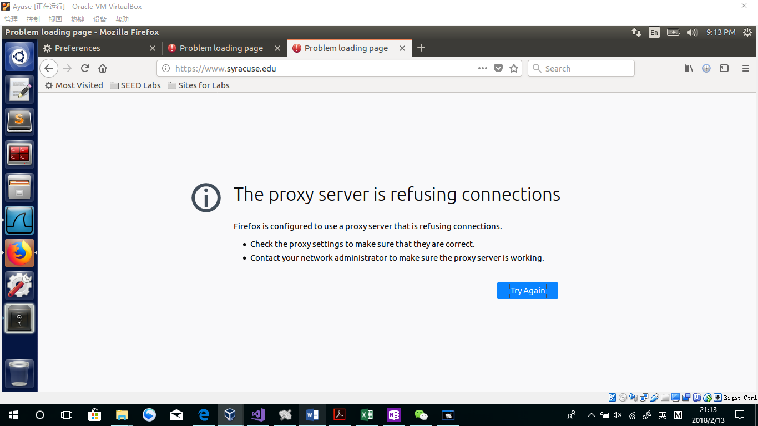

Observation:

Only domain Google.com is allowed in this try. Yahoo Website does not work, neither as Syracuse homepage.

WireShark:

When visiting Syracuse homepage which should be denied, the wireshark is like this:

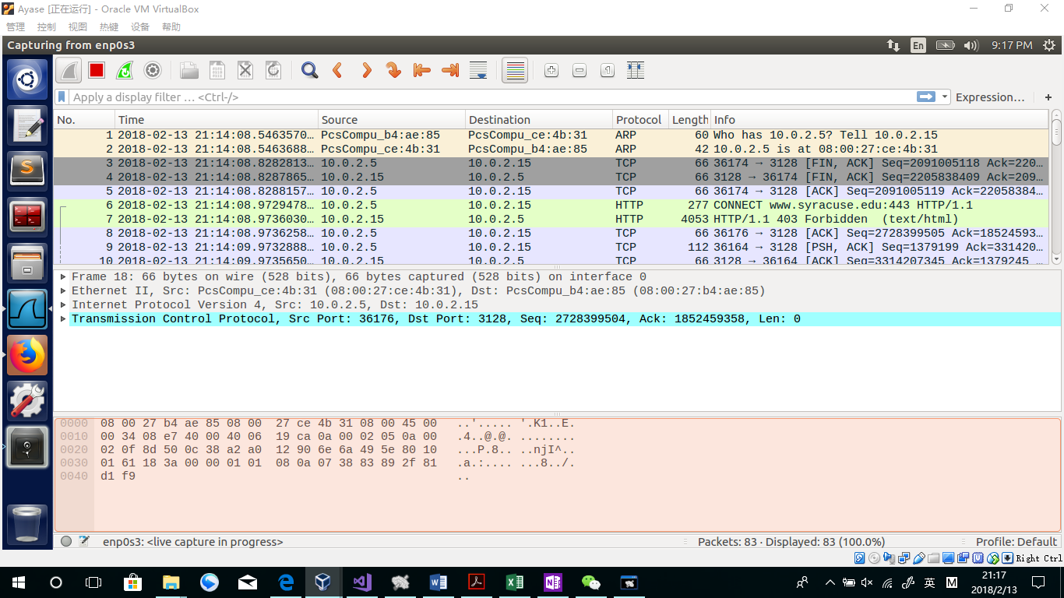

Obviously, as the Machine B(10.0.2.15) is the proxy, when there is a HTTP request in Machine A, A sent a packet to ensure if B is active. After ensuring B is active by receiving ACK TCP packets, A started to send B the HTTP request, containing the website “ [www.syracuse.edu](http://www.syracuse.edu) ”. However, Machine B checked its squid.conf file and quikly determined that the website is not allowed. As a matter of fact, a forbidden message is sent back to A, telling the browser that the website is unavailable. That is why the Syracuse homepage is not shown.

When visiting google homepage, the wire shark is like this:

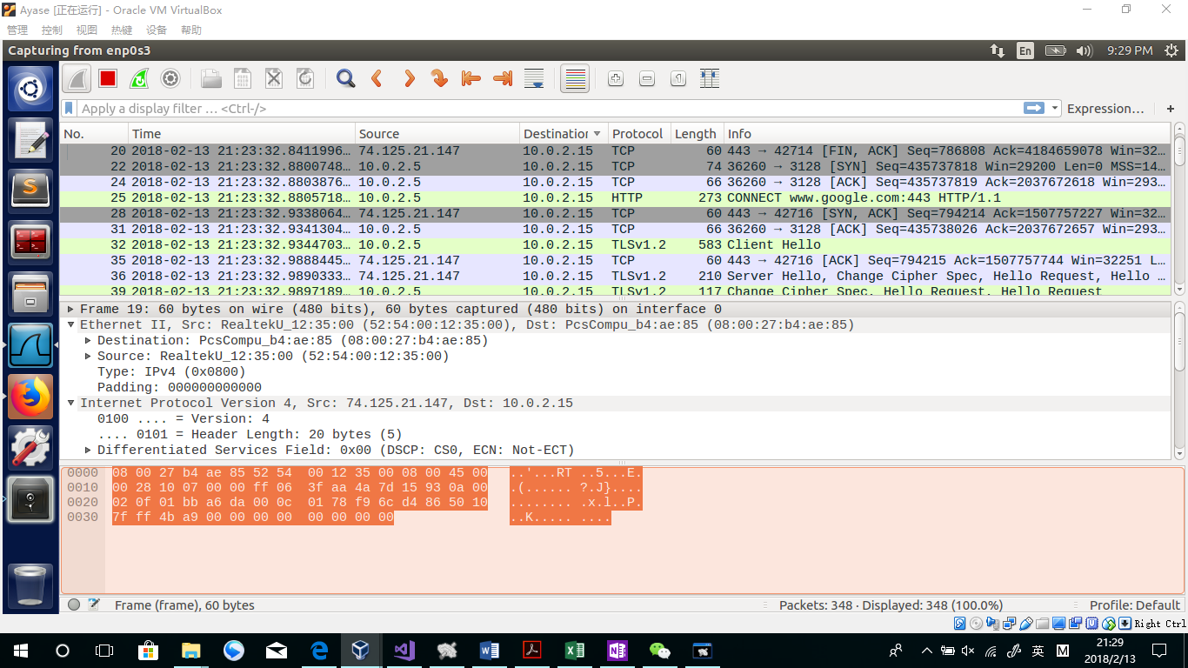

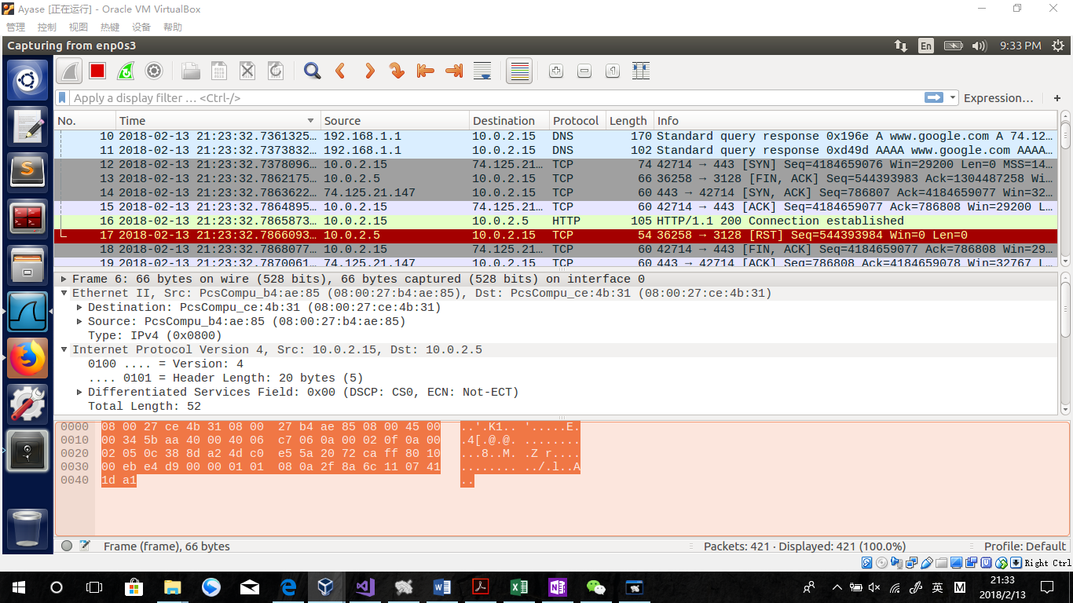

Just like I stated in the previous example, the Machine A started to check whether B is active at first. After that, the HTTP request has been sent to B. Finding [www.google.com](http://www.google.com) is allowed in the squid rule, B started to find the real ip address in its DNS server. After finding it as 74.125.21.147, B started to do TCP packets exchange to the address, and receive the contents of the website. During this period, A has been waiting so A has sent another ACK packet to ensure B is still active. After B getting all of the contents, B sent back those HTTP packets to A. That is the reason why A can receive packets from Google and browse the Google homepage.

**Task 4.b: Using Web Proxy to evade Firewall.**

First, turn off the proxy built in Task 4.a, finding we can visit Syracuse homepage.

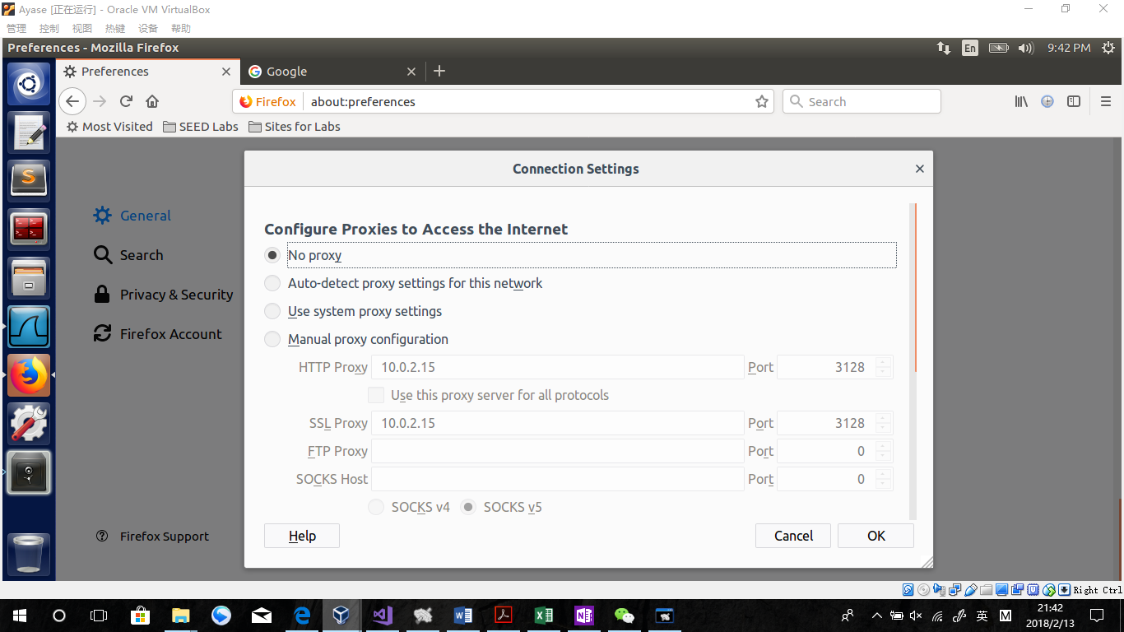

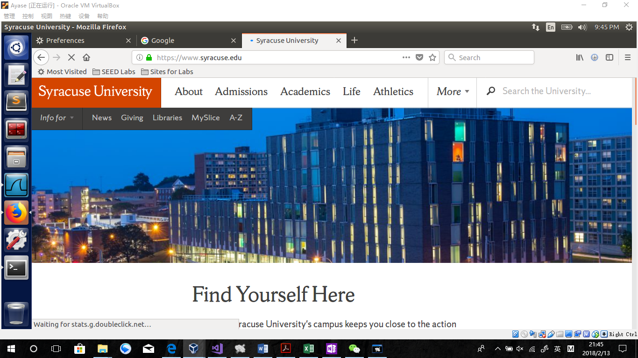

Then, add ufw rules so that we cannot visit [www.syracuse.com](http://www.syracuse.com) directly.

Sudo ufw deny out from any to 128.230.18.198



Open the proxy,

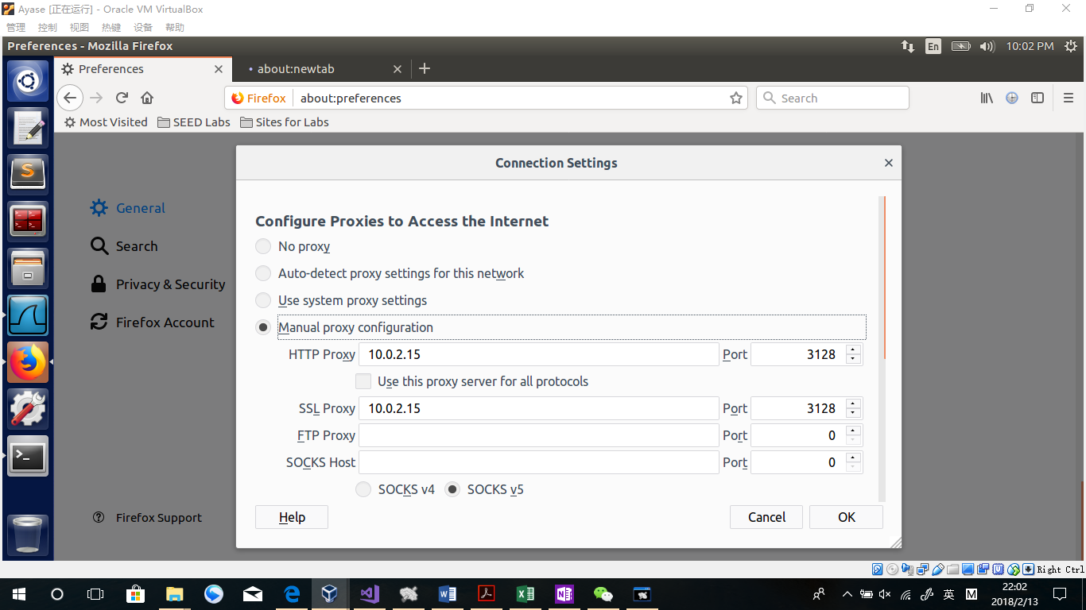

Change the squid.conf file in Machine B back to allow all

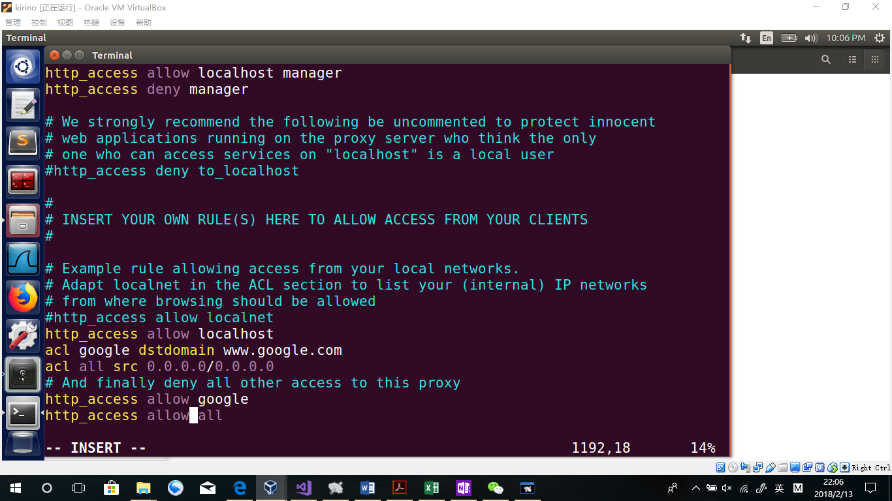

Save & restart

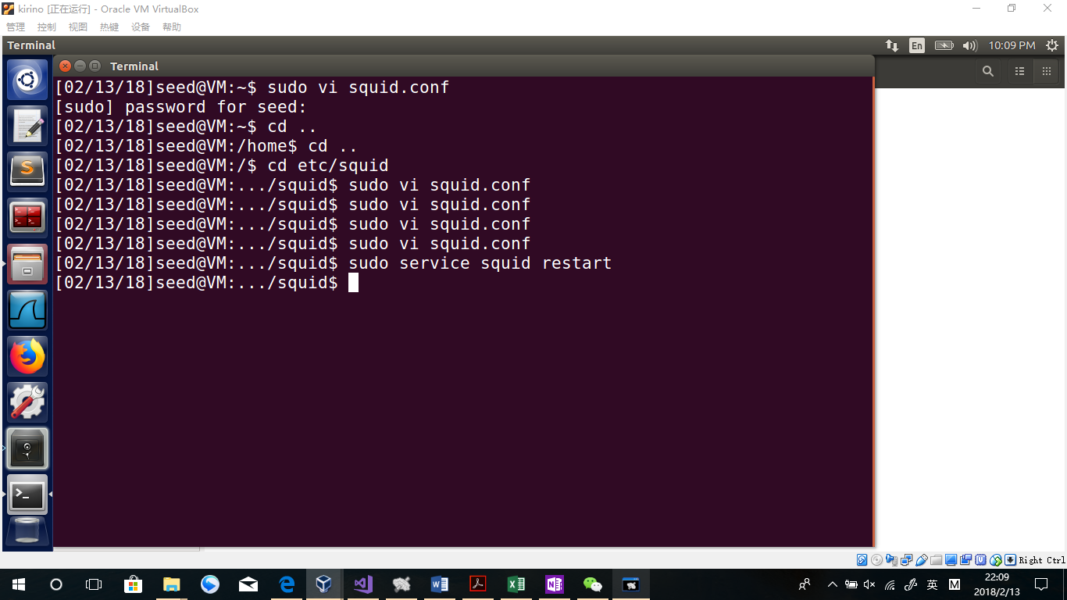

Go back to Machine A, refresh the page

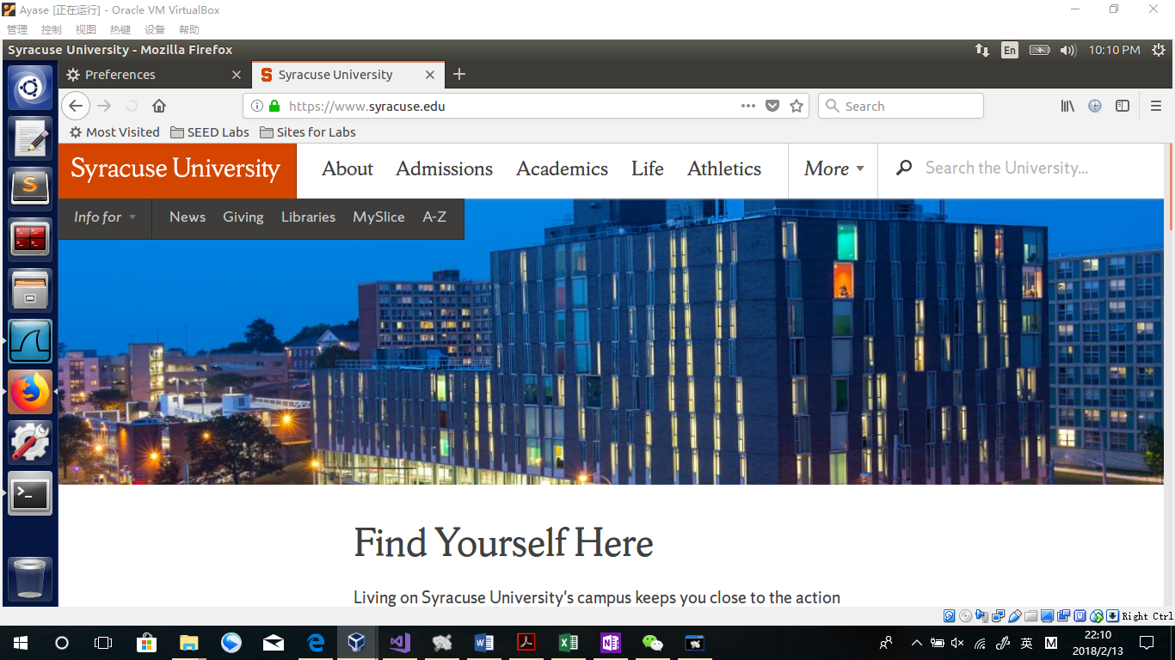

Observation:

The page is shown successfully.

Explanation:

Although this website is not allowed by ufw on Machine A, it is allowed on Machine B. Which means, A asks HTTP to B to visit this website and B visited the website and sends the contents back to A. That is why A can visit the website through the ufw.

**Question 5: If ufw blocks the TCP port 3128, can you still use web proxy to evade the firewall?**

In that case, without changing the squid service to another port, the proxy will not work successfully, because A cannot send the HTTP request to B.

**Task 4.c: URL Rewriting/Redirection.**

Add the rules in squid.conf in Machine B.

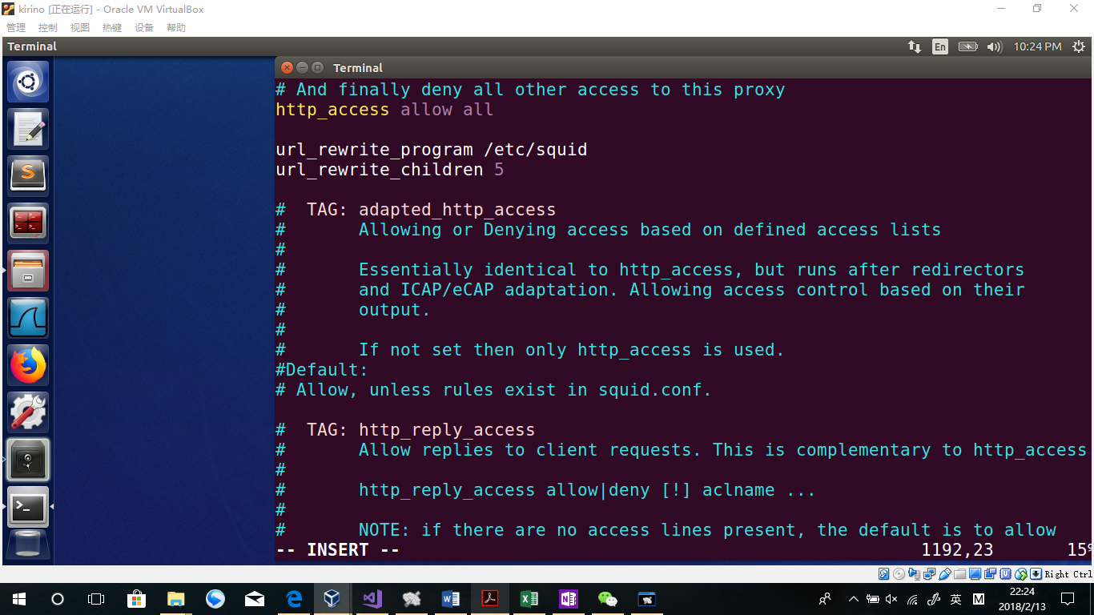

About the codes,

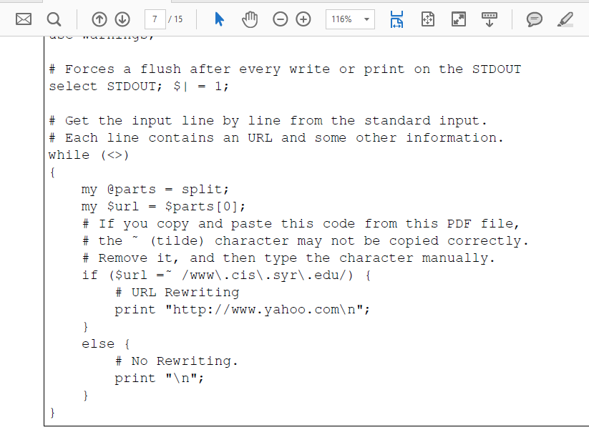

In the task the code should redirect [www.cis.syr.edu](http://www.cis.syr.edu) to [www.yahoo.com](http://www.yahoo.com) , but there is a problem that [www.cis.syr.edu](http://www.cis.syr.edu) is using https, which is not supported in this task. As a matter of fact, I will use <http://www.bbc.com> instead.

Codes are as follows:

use strict;

use warnings;

# Forces a flush after every write or print on the STDOUT

select STDOUT; $| = 1;

# Get the input line by line from the standard input.

# Each line contains an URL and some other information.

while (<>)

{

my @parts = split;

my $url = $parts[0];

# If you copy and paste this code from this PDF file,

# the ˜ (tilde) character may not be copied correctly.

# Remove it, and then type the character manually.

if ($url =˜ /www\.bbc\.com/) {

# URL Rewriting

print "http://www.yahoo.com\n";

}

else {

# No Rewriting.

print "\n";

}

}

While visiting [www.bbc.com](http://www.bbc.com), it will automatically change to [www.yahho.com](http://www.yahho.com)

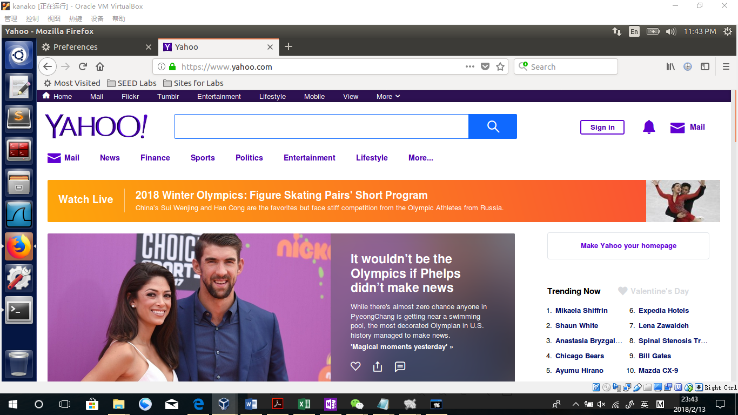

2/3

Codes are as follows:

#!/usr/bin/perl -w

use strict;

use warnings;

# Forces a flush after every write or print on the STDOUT

select STDOUT; $| = 1;

# Get the input line by line from the standard input.

# Each line contains an URL and some other information.

while (<>)

{

my @parts = split;

my $url = $parts[0];

# If you copy and paste this code from this PDF file,

# the ˜ (tilde) character may not be copied correctly.

# Remove it, and then type the character manually.

if ($url =~ /(.*\.jpg)) {

# URL Rewriting

print "http://www.cis.syr.edu/~wedu/seed/img/setup_img.png";

}

else {

# No Rewriting.

print "\n";

}

}

Explanation:

Just like the task1, we should change all the .jpg file(or png etc. as well ) to another picture. In this task I use the online pic



By doing this, all pictures should be placed by the picture above if those pictures are format”.jpg”. Just like this, we can change the Boolean to a longer one to include “gif”,”png” etc.

**Question 6: We can use the SSH and HTTP protocols as tunnels to evade the egress filtering. Can we use the ICMP protocol as a tunnel to evade the egress filtering? Please briefly describe how.**

Yes. I have done this work in the rule 4 in the task2.2. The key is that telnetFilterHook.hooknum should be changed to NF_INET_PRE_ROUTING. By doing that, egress filtering can be done as an ICMP protocol. Details can be found in rule4 test in task2.2.

Codes in task2

